RESUME
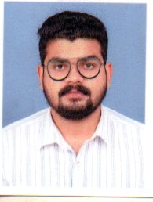
ELIAS THOMAS
Chakkenkery Puthenparambu
Veliyanadu po
Alappuzha Dist
Kerala – Pin: 689590
Mob : 9895971491 , 9747451197
Email : eliasthomas005@gmail.com
POST APPLIED : Mechanical Technician
PERSONAL PROFILE:
Name : ELIAS THOMAS
Father’s Name : Mr.P. T Thomas
Sex : Male
Date of Birth : 16/05/1996
Nationality : Indian
Religion : Christian
State of Domicile : Kerala
Marital status : Single
Languages known : English, Malayalam & Hindi

EDUCATIONAL QUALIFICATION:

- Diploma in Mechanical Engineering
- Plus Two
- S.S.L.C

ADDITIONAL QUALIFICATION

- Automation
- CATEA

PASSPORT DETAILS
Passport No : T4490425
Date of Issue : 11/02/2019
Place of Issue : Cochin
Date of Expiry : 10/02/2029

PERSONAL SKILLS
- Strong communication skill
- Good in customer relation
- Professional attitude and strong commitment to the job
- Good listener, focused sincere and hardworking

DECLARATION

I, hereby declare that all the details furnished above are true to the best of my knowledge and belief.

Place: Veliyanadu

Date: ELIAS THOMAS

