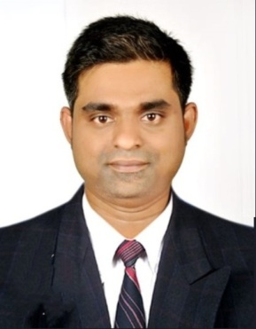
JISHAD MAJEED
DUBAI, U.A.E
MOB: 054-3863882
Email: jishadmajeed@gmail.com

OFFICE ADMIN / SALES CORDINATOR / SALES MAN

Objectives
Expert professional with 7+ years of industry experience in Middle East (Saudi Arabia, Kuwait) and India , pursuing career in a challenging environment that could provide an opportunity for learning and professional advancement to work with full dedication and honesty for my organization and devote my full potential for the progress of the organization.
Roles & responsibilities
- Provided detail-oriented administrative support to 50 + coworkers to ensure efficient office operations.
- Supported office staff by organizing company events, meetings, and scheduling.
- Assisting training department
- Making fax, copying papers, scanning, answering telephone, etc.
- Used expert knowledge of office management software to increase office efficiency by 100% using a results-driven approach.
- Answered calls, responded to emails, and served as the first point of contact between the company and key customers.
- Reviewed and analyzed complaints received from clients; oversaw major customer accounts and defined sales targets and quotas.
- Maintained all sales records, performed data entry tasks, and provided excellent customer service.
- Performed other duties as assigned by managers; awarded Employee of the Month twice for constantly increasing sales and revenue.
- Assist the customer as per their needs
- Filling, taking inventory, keeping records, preparing and binding documents
- Send and receive mails
- Filing documents as per the requirement of the office managers
- Updating files and registers related to attendance and work of the staff
- Data entry loading other necessary information into the software programs
- Official documents receipt, distribution and tracking.
- Courier distribution and tracking.
- Managing reception on rotation.
- Answering incoming calls routing them to the proper individual massages when appropriate.

Work Experience
- Worked as an Office Admin and Sales coordinator in SAFARI CO. LTD- Saudi Arabia : https://safari.com.sa/
- Worked as an Office Admin and Sales coordinator in KDDB–Project in Hyundai–Kuwait.
- Worked as an Office Admin and sales coordinator India SINGH HINDUSTAN MARINES PVT LTD
- Worked as an Office Admin and sales coordinator in Pathupara Electrical contracting and Trading, Kerala, India

Educational Attainment
- Diploma in Fire and Safety engineering from National Institute of Fire and Safety engineering, Cochin, India
- Diploma in Electrical engineering from Thiagarajar polytechnic Trissur
Kerala, India (2008)
Certification
Nebosh international general certificate (National examination board of occupational safety & health, UK)
IT Expertise
- MS Office – Word, Excel, Power Point ,Outlook
- Internet & Email
Skills
- Co Operative and patient
- Flexible and very quick learner
- Hard working and dependable
- Able to work under pressure
- Work well with a team
- Good communication skills
Personal Data

Citizenship : Indian
Gender : Male
Date of Birth : 23/05/1988
Marital Status : Married
Religion : Islam
Languages Known : English, Hindi, and Malayalam & Arabic
Visa Status : Visit Visa
Driving License : Valid Indian LMV License

Declaration
As per subject stated above, there by attaching my curriculum vitae for your kind perusal. Please feel free to contact me on the mentioned mobile at any time for an interview. Hoping for your kind consideration and awaiting for your favorable reply.

Place: Yours Faithfully
Date: JISHAD MAJEED

