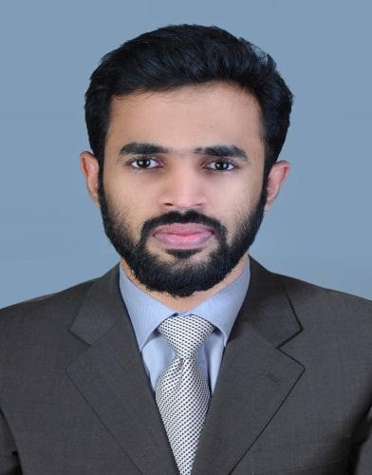  MOHAMED AMEEN KM  MOB(UAE) : +971 527739940  MOB(INDIA):+919633509129  E-mail:  mohamedameenkm@gmail.com  Date of Birth :  01st February, 1991  Sex :  Male  Nationality:  Indian  Languages Know English ,Malayalam,Hindi  and Tamil  Permanent Address:  Kaliyarakath Manath parambil, M G Road Nalakam, Maranchery (PO), Malappuram (Dist), Kerala, India  Passport Details:  Passport No: K8517232  Visa Status : Visit visa | RESUME  Career Objective  To establish myself in a professionally run organization that provides a challenging work environment for both career and personal growth. I believe that the knowledge and experience gained at various stages of my professional as well as educational life will help me in achieving my organizational and career objectives.  Academic Profile  - Bachelor of Commerce, University of Calicut, India. (2010 - 2012)  - Plus Two, Board of Higher Secondary, Government of Kerala (2008 - 2009)  - SSLC (Secondary School Leaving Certificate) – Govt. of Kerala (2007)  Work Experience  AL HUSSAINIYA CHARITY TRUST, Ponani, Kerala  Position: ACCOUNTANT  (From: May 2018 – Jan2022)  Responsibilities:  - Handling all day to day accounting  - Petty cash management & cash book reconciliation.  - Maintaining proper records of all the employees of the company i.e., Advances, Loans, etc.  - Guest register maintenance  ROMAI ELECTRICAL BIKE, Edappal, Kerala  Position: ACCOUNTANT CUM SALES  (From: June 2016 – February 2018)  Responsibilities:  - Handling all day to day accounting up to finalization of books of accounts.  - Help customers find items in the store.  - Maintaining proper records of all the employees of the company.  - Booking Monthly Expenses.  - Keep track of inventory.  - Preparation of Bank Reconciliation Statements.  THOUFEEQ & ASSOCIATES (TAX PRACTITIONER’S & AUDITORS)  Edappal, Kerala  Position: : ACCOUNTANT  (From: March 2013 – May 2014)  Responsibilities:  - Interacting with clients.  - Assisting with tax auditer  Computer Proficiency  - MS-Office, Windows XP  - Tally ERP 9  Strength  - Capable of working in a fully computerized environment  - Able to handle independently and under pressure and good team player  - Good interpersonal and ability to realize with people of different culture  - An Ambitious & Hard working individual with ability to manage time effectively  - Good communication and Analytical skills  Hobbies  Reading, Travelling,  Reference  Shall be provided on request.  Declaration  I hereby declare that the above mentioned are true and correct to the best of my knowledge and belief.  MOHAMED AMEEN KM

