ALSUYUTI IDRIS BASHIR
Dubai UAE : 00971543784270

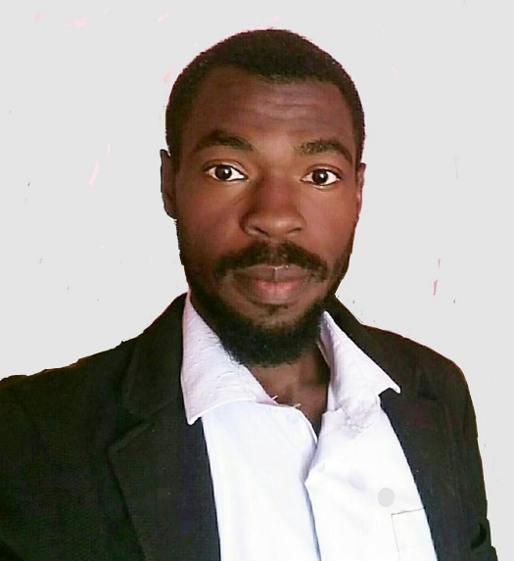
- Dubai - UAE
- Call / wattsap : 00971543784270 |
Alsuyuti.idris@gmail.com

I’m with high willingness of learning and development and I have very good communication skills in both Arabic and English languages
- EDUCATION:
- Diploma in Electronics engineering from International university of Africa 2015
- Electrical safety Training program: at charisma workforce development on 15th march 2020.
- Risk Assessment program: at charisma workforce development on 19th march 2020 Safety and firefighting training course at Civil Defense General Administration (25 November 2017

- PRACTICAL SKILLS:

- Good at using of computer and Microsoft office (Excel , word )
- Very good experience in sales and customer services
- Fast learning and ability to work under pressure
- Very good experience in warehouse and procurement management
- Installation and maintenance of power solutions
- Installation of different types oh Genset
- Sudanese driving licence
- EXPERIENCE:

    - Warehouses in charge for Sabal telecom solutions (10/2/2021 To 15/8/2021).

    - Salesman : at Excellency services center (1/4/2019 up to 12/1/2021)

    - Afro king factory as production worker from (2017 ~ 2019)
    - Alkhaleeg factory as worker in plastic department (2015 To 2016).
    - Security guard at Alhadaf security company (HASCO) from (2012 up 2014)

