1-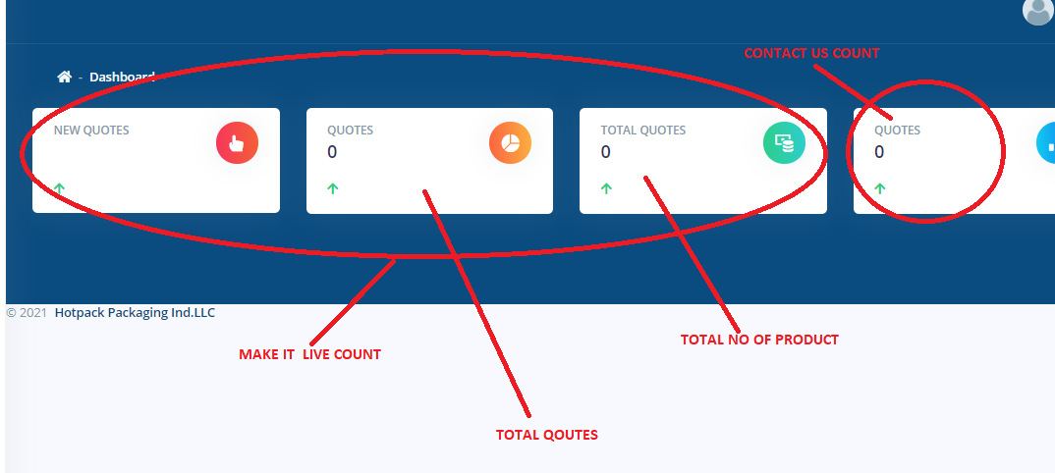
2-Add slider caption in slider adding section
3-news and events – read more not working in front end
4-awards read more not working
5-Need to make sales centre dynamic
