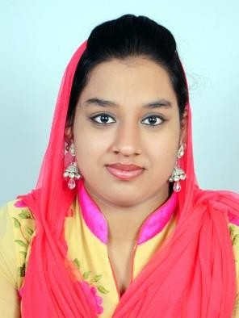
NABLA
nablaiqbal@mail.com

+91 7994268215

OBJECTIVE

To secure a challenging position in a reputable organisation to expand my learning, knowledge, and skills.

PERSONAL &

PROFESSIONAL

PROFILE

2013- Passed 10th (CBSE)
2015-Passed 12th (State Syllabus) 2019-Passed BBA

TECHNICAL SKILLS

HARDWARE & SOFTWARE
- MS Excel
- MS Word
- MS PowerPoint
- Presentation Skills (Preparing &Presenting Presentations)

EDUCATIONAL BACKGROUND

- 2013 – Secondary education, NIMS, Dubai
- 2015 – Higher Secondary Education, ASHSS, Parippally, Kollam
- 2019 – Bachelor of Business Administration, Kollam

LANGUAGE SKILLS

English and Malayalam

PERSONAL DETAILS

Marital Status: - Married Date of Birth: - 07/10/1997 Nationality: - Indian Religion:-Muslim
Contact Address: - Varuvila House,
Chavercode, Palayamkunnu PO Trivandrum, Kerala

DECLARATION

I, Nabla hereby declare that the information contained herein is true and correct to the best of my knowledge and belief.

NABLA Date: -

