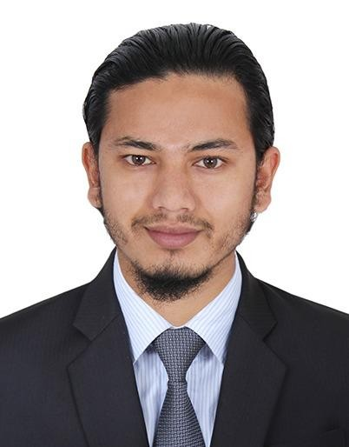
PROFILE
I’m having experience of 3 years as a Sales Executive at Reliance Mart, Bangalore, India.
Currently I was working as a Senior Sales Executive.
I’m currently staying in Dubai and seeking for the Good Opportunity. I’m comfortable to relocate to any locations in Dubai.
I can join Immediately.

CONTACT
PHONE:
+971 582575479

EMAIL:
Rumaanahamed26@gmail.com

HOBBIES
Playing Cricket and Volley Ball. Travelling.

RUMAAN AHAMED

EDUCATION
PRE-UNIVERSITY EDUCATION
Sri Venkateshwara Pre-university College. (March 2016) Hassan, Karnataka, India.
SSLC
KUVEMPU VIDYANIKETHAN HIGH SCHOOL. (April 2014)
CHICKMAGALUR, Karnataka, India.

WORK EXPERIENCE

Feb 2018 – March 2021
Sales Executive• Senior Sales Executive • Reliance Mart, Bangalore, Karnataka, India.

KEY SKILLS
- Good Communication skills.
- Good Co-ordination skills.
- Active Listening Skills.
- Product Knowledge, Teamwork.
- Accurate Documentation, Money Handling.
- Analytical thinking, Time management.
- Sales. Marketing, Cashier.
- Sales Forecasting, Sales Analysis.
- Customer Service, Customer Support, Customer Behavior.
- Good presentation skills.

TECHNICAL SKILLS

MS WORD, EXCEL, POWERPOINT.

LANGUAGES KNOWN
English, Hindi, Urdu, Kannada

PERSONAL DETAILS
Date of Birth :26/05/1999 Gender :Male Marital Status :Married Nationality :Indian
Visa Status :Visit Visa (May 2022)

Declaration:
I hereby declare that all the above information is correct to my knowledge, and I bear the responsibility for the correctness of the same.

PLACE: DUBAI

YOURS SINCERELY
(RUMAAN AHAMAD)

