CURRICULAM - VITAE

ASHIM 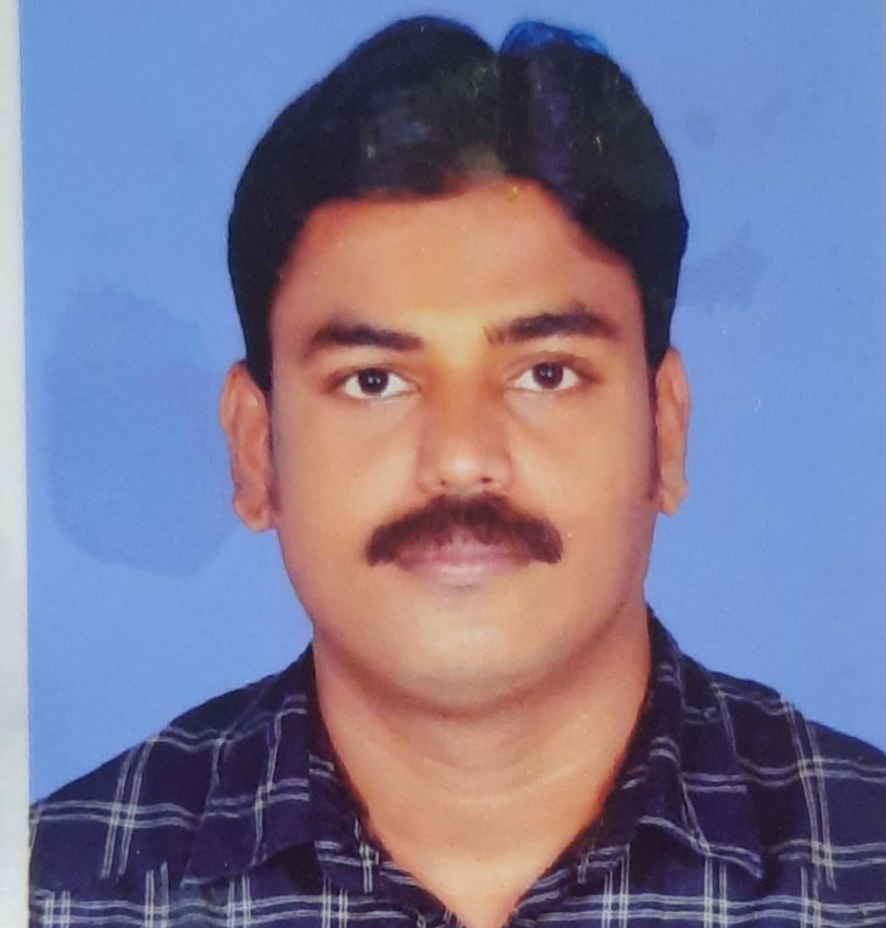
Araykkal Parambu
Mukkolakkal,
Chungam ward,
Alappuzha
Kerala,
S. India -
Pin. 688 012
Mob: 9947222215
mail: ashimkasim2661979@gmail.com

Objective

To Work in a creative and challenging environment, where I can prove my abilities and I can constantly learn, improve and successfully be an integral part of institution with a responsible position.

Work Experience
Period : 11 years
Firm : Hamzathul Hanan Trading Est. Saudi Arabia
Rawda, Riyad

Work Profile : SHOP INCHARGE

EDUCATION QUALIFICATION : SSLC

COMPUTER AWARENESS:
Operating System :Dos, Windows,
Office Packages : MS Office,

PERSONAL DETAIL

Date of birth : 26.07.1979
Fathers Name :. Kassim
Mother's Name. : Arifa
Nationality : Indian
Religion : Muslim
Languages Known :. English, Hindi, malayalam & Arabic

Permanent Address : Asif Manzil
(Malikaparambil)
South Aryad
Avalookunnu P. O.,
Alappuzha,
Kerala

Driving License : LMV & Two wheeler

Passport Details : Passport No. : K9731740
Date of Issue : 21.08.2013
Date of Expiry : 20.08.2023

DELARATION
I hereby that the above information are true and correct to the best of my knowledge and belief

Place: Alappuzha yours faithfully,
Date. 02.01.2021 ASHIM

