Curriculum Vitae
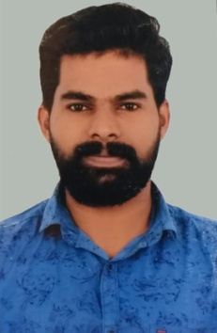

ABDU MANAF PARAMTHOTTI

Mobile: +918891703552, +919656898891
Email: abdu60311@gmail.com

Career Objective

To utilize my skill and knowledge to grow professionally and intellectually and thereby make a positive contribution to your organization
Personal Details

Name : Abdu Manaf P
Gender : Male
Date of Birth : 05/01/1991
Marital Status : Single
Nationality : Indian
Address : Paramthotti House Pariyapuram Post
Malapuram Dt –Kerala, India -676302
Passport No : J2730249 Valid 09/2010 to 09/2020
Driving License : India & KSA

Summary of Skills:

- Ability to work in a team
- Willingness to learn
- Excellent communication interpersonal skills.
- Positive attitude
- Good Communication Skills

Educational Qualifications:

SSLC – March 2009
Secondary Education
Devadhar govt higher secondary school

HSE – March 2011
Higher Secondary Education
Govt higher secondary school kattilanghadi Tanur

Spoken English Class Attended – 6 Month Course

Languages

English: Read, Write& Speak
Arabic: Read, Write & Speak
Hindi: Read, Write & Speak
Malayalam: Mother Tongue

Experience

- 4 year experience in Saudi Arabia as a House Driver
- 4 year experience in Famous Bakery as a Sales Executive & Driver

Declaration

I hereby declare that all information stated above is true to the best of my knowledge.

Place: Malapuram Sincerely,
Date: 03/01/2020
Abdu Manaf Paramthotti

