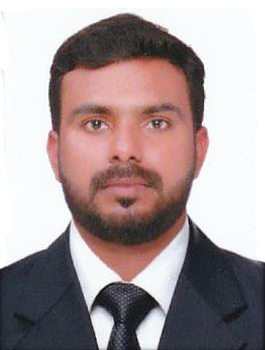


Objective
To build up a challenging career with an organization where I can explore and use my talents and aptitude towards the integrated development of the organization, myself and society

Educational Qualification
- B.Com from University of Calicut, 2011
- HSE (12th) from Board of HSE Kerala, 2008
- SSLC (10th) from Board of Public Examination Kerala, 2006

Experience
- Transaction Processor (8 Years, 2014-2022)
Kochi Infopark Conduent India Pvt. Ltd.
- Data Analyst (2 Years, 2012-2014)
Kochi Infopark Conduent India Pvt. Ltd.
- Sales Man (1 Year, 2011-2012)
Reliance Supermarket Oboronmall Kochi
- Godown Supervisor (1 Year, 2012-2013)
Reliance Supermarket Oboronmall Kochi
- One year experience in Bajaj Finserve Under Business Development Team

Skill
- Data Entry

Personal Profile
Date of Birth : 04-03-1991
Gender : Male
Nationality : Indian
Mother Tongue : Malayalam
Marital Status : Married
Visa Status : Visit Visa

Passport Details
Passport No : M8441693
Date of Expiry : 04/05/2025

Declaration
I solemnly declare that the information give above is true and correct to the best of my knowledge and belief.
AMAL CHANDRAN P.S

AMAL CHANDRAN P.S

Contact
0506865435
amalchandran1000@gmail.com

Languages
- English
- Hindi
- Malayalam

Strengths
- Responsible
- Ability to Work Hard
- Confident
- Co-ordinate & Friendly
- Good Interpersonal Skill

