CURRICULUM VITAE

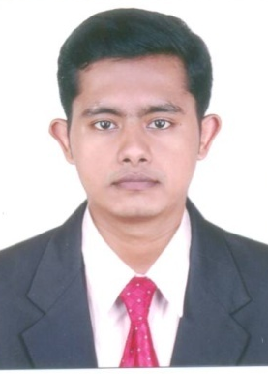
ARUN MATHEWS

PANTHALIPPADAN(H)

P.O. PULLUR,THURAVANKADU,

IRINJALAKUDA,THRISSUR(DT)
KERALA, INDIA PIN:680683
PHONE;8129107167,9633851431

EMAIL:-arunmathews123456@gmail.com

Personal Details

- Father’s Name - Mathews P.M
- Date of birth - 20-09-1994
- Sex - Male
- Marital status - Single
- Religion & Caste - Christian – RC
- Nationality - Indian
- Languages known - English & Malayalam,Tamil

Education

- Fibre Optics Technology (TUV Rheinland Nife Acadamy Pvt. Ltd. Thrissur)
- Advanced Diploma in DTP & Graphics – A Grade (IRS Computers & Communications (P) Ltd. Irinjalakuda)
- Plus Two - Second Class (Keets College, Amballur)
- S.S.L.C. - First Class (Namboodiri’s College, Irinjalakuda)

Knowledge of Fibre Optic Technology

- Prepare Fibre Cable to the enclosure
- Splicing and rooting to cable in enclosure
- Preparing RJ 45 connector
- OTDR Testing
- Preparing SCPC Connector
- Measuring

Work Experience

Worked as a Fibre Optic technician (SFO TECHNOLIGIES PVT.LTD.) Cochin,Kakkanad, Kerala, India for the last two years.

Worked as a cashier (sasco palm co. A LIMITED LIABILITY
COMPANY)Saudi Arabia for the last two years.

Extra Curricular Activities

Karate (Brown IV Belt) from SHO SHIN KAN KARATE ASSOCIATION

Passport Details

Passport No. | : | T5568872
Date of Issue | : | 22.05.2019
Date of expiry | : | 21.05.2029
Place of Issue | : | Cochin

Declaration

I hereby declare that all the information given above are true and correct to the best of my knowledge and belief.

Place : Irinjalakuda
Date : ARUN MATHEWS

