SUGUMARAN P 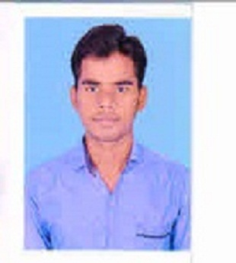
sugumarandece@gmail.com
Contact No : 95668 06064, 75388 83878
CAREER OBJECTIVES
Seeking a position where I can prove my excellent service with maximum skill and marvellous work experience.
EXPERIENCE:
2 years work experience in CEAT tyres pvt ltd as Management executive in Technical stream.
One year in green plant project at CEAT TYRES.

ACADEMIC QUALIFICATION
COURSE | BOARD | NAME OF INSTITUTE | YEAR OF PASSING | PERCENTAGE
D.E.C.E  (Diplomo in Electronics andcommunication Engineering | DOTE | ArasanGaneshan Polytechnic college | 2018 | 92%
HSC | State Board | S.H.N. Edward higher secondary School | 2016 | 70%
SSLC | State Board | St.Theresa’s High School | 2014 | 90%

SKILLS
- Good Communication
- Team Player
- Fluency in Tamil ,English,Hindi,and Telgu
- Willing to walk an extra mile towards success
- Ability to learn others culture and get going with them
- Problem analysis
- Traceability and troubleshooting
- Handling man power.

AREA OF INTEREST
- Ground Handling
- Shift handling and manpower handling.
- HMI operation.
- Electronic Devices And Circuits
- Problem troubleshooting

CO CURRICULAR
- Attended Seminars Based on Electronics Topics
- Presented Mini Project in Expo held by inter college
- Completed Course in Bio-Medical Instrumentation Course and Design of Analog and Digital Circuit
- Completed DTP Course in CSC
- Attended Paper Presentation Contests held in Outer Colleges

EXTRA CURRICULAR
- Won First Prize in Pole Vault
- Participated in JRC Camps
- Got distinction in talent Exam about problem identifying

AWARDS AND ACHIEVEMENTS
- Got Inspire award given by State Government
- Got Gold Medal in Inter college Pole Vault Competition
- Participated in Sivakasi Marathon

TECHNICAL SKILL
- Windows Applications: MS Office
- Problem analysis.
- Solving skills with 7qc tool
- HMI operation

BIO DATA
Father’s Name : P.Perumal Samy
Mother’s Name : P.Durga devi
Date of Birth : 27-8-1999
Address : 3/272, West Street, Iyyambatti,
Gollapatti (PO), Sattur – 626 203.
Nationality : India
Gender : Male
Marital Status : Single
Language Known : Tamil, English, Hindi & Telugu

Passport Details:
Passport Number : S1994112
Issued Place : Madurai

DECLARATION
I do hereby that the above given statements are true and correct to the best of my knowledge.

Place :

Date : Signature

(SUGUMARAN.P)

