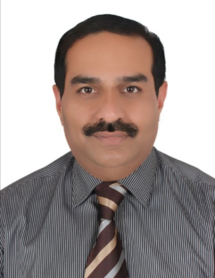

SAID SHIHABUDEEN SAID JALEEL
Location:Dubai,UAE

/Mob: 050 4951688,Email: said.shihab@gmail.com, https://www.linkedin.com/in/said-shihabudeen-8850245a
Profile Summary
Self-motivated and highly knowledgeable Accounts Receivable specialist experienced in credit control, tracking and auditing incoming funds, Manage the general ledger, prepare monthly A/R reports, and coordinate the activities,Work collaboratively with vendors and employ exceptional client management skills.
Core Competencies
- Accounts & Administration
- Credit control
- Sound knowledge of Computers & Accounting Packages
- VAT Compliance
- Team work and dedication
- Ability to work hard
- Sound Knowledge of SAP
- Advance Level User of MS Office Suite
- Knowledge of Banking procedures
- Performs well under pressure
- Client Relationship Building
- Multitasking ability
- Communication skills
- Keeps abreast of latest methods

Career History
Al Rashideen Trading & Distribution Of Tobacco Products LLC, Dubai, an FMCG company, distributor for Marlboro Cigarettes in UAE and distributor for various other products like La vache quirit cheese, Leisure Oil, Ocean Spray Juices and Gulfa Water
Presently working as Credit Supervisor, Joined the company as Accountant
May 2004 to present
Reporting to the Credit Manager of the company and currently supervising the Consumer Division with 5 staff reporting.
- Responsible for the completion of Division Accounting and coordination with Head Office to ensure the collections received as per the target
- Responsible for accounting functions such as Accounts Receivables, Bank Reconciliation and Receipt Allocation
- Assist the chief accountant in the preparation of profit & loss a/c and balance sheet
- Release or hold the credit orders as per credit policy to minimize the risk.
- Periodic review of credit limit to minimize the risk and to avoid Bad Debts.
- Perform trade reference enquiries of all new clients as part of Risk Assessment
- Tracking agreed payment terms through analysis to avoid disputes.
- Prepare month end reports like AR Status, Credit limit Review, Risk Assessment and Blocked Customers.
- Overseeing routine functions like generation of Tax Invoices, Tax credit notes, and Adjustments
- Getting the Balance Confirmation from the customers before finalization of accounts.
- Overseeing the complete Bank Transactions.
- Analysis of Ageing report and follow up with sales department and customers for realization of outstanding amount.
- Preparing Tax Credit Notes for Display Rentals and Rebates as per contracts with key Account Costumers and Hyper Markets.
- Responsible for preparing the Consolidated Statement of Account for National Account Customers like Carrefour, Lulu, All cooperative societies, Spinneys etc.
- Carrying out Debtors reconciliation with the customers in case of discrepancies.
- Responding to all queries from Debtors and arrange meeting as and when required.
- Administering the activities of Accounts Department and Warehouse
- Managing VAT compliance and submission of return on time
Key Achievement
- Was instrumental in achieving 95% of the Branch collection target
- Successfully finalized and generated the SOA on the last day of every month.
- Promoted in 2010 as Credit Supervisor

Education
- Bachelor of Commerce(B.Com) from Calicut University,Kerala,India
- Post Graduate Diploma in Personnel Management (PGDPM) from National
Institute of Personnel Management, (NIPM), Calcutta, India
Personal Details
- Languages known : English, Arabic, Hindi, Malayalam, Tamil
- Nationality : Indian
- Visa Status : Residence Visa
- Driving License : Valid UAE Driving License
- Alternative Mob:055 9955831
Reference

Mr. Abdulla Sultan Al Sabbagh
General Manager
Platinum Taxi, Ajman-U.A.E
Mob: 050 5515717
LinkedIn:https://www.linkedin.com/in/abdulla-sultan-al-sabbagh-b8428815a/

