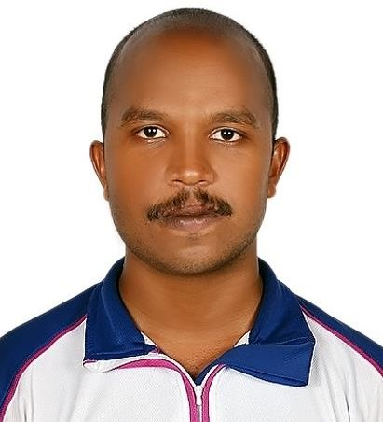
CURRICULUM VITAE
ANEEJ ANILKUMAR
Email : aneejaneej398@gmail.com
Mob : 0506908145
Objective

Looking for opportunities where I can apply my best skills and performance to enhance and explore my abilities and willingness to learned for any job from establishment of organization.
Personal Information

Ha Name : Aneej
Address : Al Nakheel Ras Al khaimah
Date of Birth : September- 13- 1997 Age : 23 years old
Gender : Male
Civil Status : Single
Citizenship : India
Educational Attainment
High school ( S.S.L.C) : St Joseph Highersecondry School Year 2012 - 2013
Higher Secondary : Government Model School Thycaud Trivandrum Year 2013 – 2015
Bpo : Transorze Institution Ambalathara Year 2019
Language Spoken
- English, Hindi , Malayalam
Work Experience
- Company : Life Pharmacy
Position : Support Staff
Address : Al Hamra , Ras Al Khaimah

- Company : Duron
Position : Sales Staff
Address : East fort Trivandrum

- Company : KFC Restaurant
Position : Cashier
Address : Pattom Trivandrum

Duties and Responsibilities
- Check with customers to ensure that they will satisfied and take action to correct any problems and communicate with customers to resolve complaints and ensure satisfaction.
- To give what they need and give more attention to treat them properly
- Take order and serve food and beverages to patrons at tables in dining establishment.
- Conduct inspection of vehicle before departing to deliver goods.
- Pack and load products according to company specification.
- Maintain ongoing communication from back customer.

Declaration
I hereby certify that the above information is true and correct to the best of my knowledge and beliefs.

