RESUME

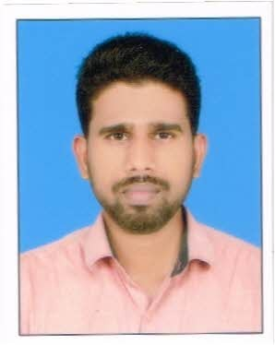
MUHAMMEDSHEFEEQKM
Karimbi HouseThiruvathraThrissur DistKerala
india
Mobile:+919567299409(india)
Email:muhammedshefe900@gmail.com

CAREEROBJECTIVE:
To take up a career in a globally challenging environment andcontribute my best to the demands of the area. where my skills can beeffectivelyutilizedandgathernewexperienceandknowledge

PROFESSIONAL QUALIFICATION:
Diplomaininstrumentation

EXPERIENCEDETAILES:
- IhavesixmonthsexperienceasaElectricalandinstrumentationAssistantTechnicianatJBFPetrochemicalsBajpe, Mangalore

ACADEMICRECORDS:
- BACalicutUniversity,India
- Plus Two (+2) under Kerala Board of Higher SecondaryEducation, Kerala, India
- 10thfromKeralaBoardofpublicExamination,Kerala,India

COMPUTERKNOWLEDGE:
  - GoodknowledgeregardingMSOFFICE

LANGUAGESKNOWN:

• | Speak | - English,Hindi,Urdu,Malayalam
• | Read | - English,Malayalam,Hindi,Arabic
• | Write | - English,Malayalam,Hindi,Arabic
STRENGTH:
    - Goodcommunicator
    - LeadershipQualityPERSONALPROFILE:
Father’sName : MuhammedAli
DateofBirth : 27.04.1991
Gender : Male
MaritalStatus : Unmarried
Nationality` : IndianMotherTongue : Malayalam

PASSPORTDETAILS:
PassportNo : M9420690
DateofIssue : 19/06/2015
DateofExpiry : 18/06/2025
PlaceofIssue : CochinDECLARATION
Iherebydeclarethattheinformationfurnishedaboveistrue.

Place:KERALA,
Date: MUHAMMEDSHEFEEQKM

