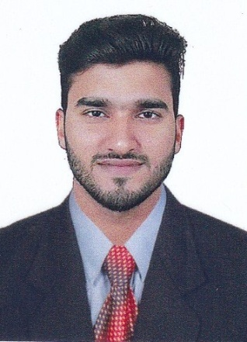
CURRICULAM VITAE

ABDUL NASEER KAIRANGALA
Mob: +91 9743122003

Email : naseerkairangala@gmail.com
Mangalore, Karnataka

Post applied for STORE SUPERVISOR
CAREER OBJECTIVE :

To associates myself with a professionally driven esteemed organization which offer continuous challenges and excellent growth prospects, where I could contribute significantly to the organization where I can apply the best of my knowledge and strive to achieve success for the organization and myself.
PERSONAL INFORMATION :

Name : ABDUL NASEER KAIRANGALA
Father Name : Mohammed D.
Date of Birth : 14-07-1995
Sex : Male
Religion : Muslim
Marital Status : Single
Nationality : India
LANGUAGES :

- English,Arabic, Hindi, Bengali,Kannada, Tamil, Telugu, Malayalam

EDUCATIONAL QUALIFICATION : :

Qualification | University
Bachelor of Commerce | Mangalore University, Mangalore (2017)
Pre University Education | Vishwamangala Pre University College, Konaje (2011-2013)
High School | Govt High School Montepadavu Naringana (2008-2011)

ADDITIONAL QUALIFICATION :

- Accounting Software, TALLY ERP - 9

EMPLOYMENT HISTORY :

- Worked as Accountant
- Accountant at seva sindu govt office Bangalore
Duration: 2Years
- Worked as Accountent

- Junior accountant at BESCOM OFFICE Doddajala Gate, International Airport Road Bangalore.
Duration : 1 Years
- Accountent at ID Food supply company Kotekar Beeri Mangalore
Duration : 3year (still working)
DUTIES AND RESPONSIBILITIES :

- Checked guests in assuring that have a perfect start to their vacation
- Assistant guests in planning their activities dining, transportation etc
- Maintained the highest standards and quality on the concierge level and in the concierge lounge.
- Thought new cast members to multi task while staying current with vast product knowledge.
- Recorded guest comments or complaints, referring customer to manager as necessary.
- Assistant guests with any special request during their visits.
STRENGTHS :

- Excellent communication skills.
- Excellent time keeping skills & great track record with punctuality.
- Fluent English speaker who is able to communicate confidently & Effectively.
- Self motivated and always ready to face challenges.
EXTRA CURRICULAR ACTIVITIES :

- Participated inter college volleyball match
- Participated inter college football match.
PASSPORT DETAILS :

Passport Number : P2579247
Place of Issue : BANGALORE
Date of Issue : 10-06-2016
Date of Expiry : 09-06-2026
DECLARATION :
I hereby declare that the information furnished above are true and the best of my knowledge and belief.
Date:
Place: ABDUL NASEER KAIRANGALA

