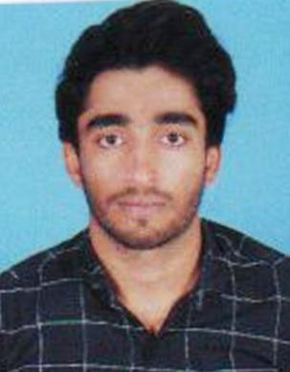
PERSONAL PROFILE

Full Name

:

MOHAMMED IQBAL

Date of Birth
:

25/06/2001

Passport No

:

V3227128

Nationality

:

Indian

Gender

:

M
ale
Visa Status

:

Visit Visa
Mobile

:

+971
-
566904947
Email

:

mohammediqbalb21
@gmail.com

Address : Bakkaravalli, Malasavara (po)
Belur Thaluk, Hassan Karnataka, India
CAREER OBJECTIVE:

I am to assume a position of responsibility at an appropriate level in the Organization, which will utilize my background, abilities and interests while providing opportunity for growth and advancement both for Organization and myself.

PERSONAL SKILLS:

Comprehensive problem solving abilities, analytical and logical thinker, good verbal and written communication skills, ability to deal with people diplomatically, willingness to learn and team facilitator.

Educational Profile:
SSLC - Karnataka Secondary Education Board.
PUC – Department of Pre-University Education Board.
Diesel Mechanic – NCVT NEW DELHI Education Board.

Special Skill:
  - Reading News Paper & Magazines, Watching News, Reading Books etc.
  - Playing Cricket, Volley Ball & Kabaddi.

Extra Curricular Activities:

- Participated in National Level Kabaddi Championship held at Telangana

Work Experience :

- Bosch Pvt.Ltd at Bangalore

- Honda bike manufacturer department at Bangalore

Languages known:

English, Hindi, Kannada, Tulu , Malayalam

Personal Attributes:

- Good Attitude, Ability to communicate, Co-ordinate with internal and External Departments, Organizing and Good Team Player.
Declaration:

I hereby declare that the information furnished above is true to the best of my knowledge.

Date: MOHAMMED IQBAL

