BIODATA

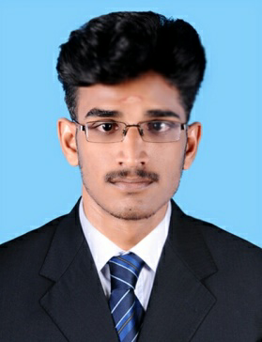.
SREETHUL C.
CHERIYERI HOUSE,
PILASSERY POST,
KUNNAMANGALAM,
KOZHIKODE DISTRICT,
KERALA STATE – 673 571
MOB. No.: +91 7510446071
;+91 9656866961(home)
E-MAIL: sreethulsree06@gmail.com
:sreethulsree6@gmail.com
CAREER OBJECTIVE
To utilize my skill and knowledge for the growth of the organization. To work with supportive subordinates and maintain good relationship with superiors.
PERSONAL DETAILS
Date of Birth : 06-12-1994
Sex : Male
Father’s Name : Sreenivasan N
Mother’s Name : Vinodini P
Religion : Hindu
Marital Status : Single
Nationality : Indian
Hobbies : Reading Books, Traveling
SOFT SKILL
- MS Office Self-Confidence.
- Handling Pressure. Time Management.
- Strong Work Ethic.
LANGUAGES KNOWN
Language | Read | Write | Speak
Malayalam | ✓ | ✓ | ✓
Hindi | ✓ | ✓ | ✓
English | ✓ | ✓ | ✓
Professional Experience
Company name | Position | Functional area | Duration
SMSA express trans.co Ltd | Handler | *Data entry  . *scaning  . *sorting | 3year

QUALIFICATION (ACADEMIC)
Course | College / Institution | Board / university | Year of Passing
SSLC | HSS, Kunnamangalam | Kerala State Board | 2010
Plus Two  (Commerce) | HSS, Peringalam | Kerala HSE | 2012
QUALIFICATION (COMPUTER)
Course | College / Institution | Board / university | Year of Passing
Diploma in Financial Accounting | NIELIT, Kozhikode | NIELIT | 2013
Certificate Course in AutoCAD | CAD Campus, Kozhikode | CAD | 2015

DECLARATION
I hereby declare that the above furnished details by me are true and correct to the best of my knowledge and belief.
Place : Kunnamangalam
Date : Signature

