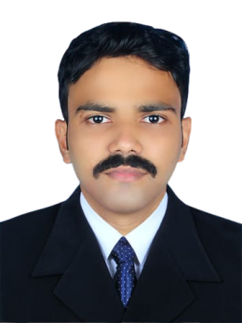
CURRICULAM VITAE
MOHAMMED IRSHAD T
Ajman, UAE
050-9038 764
Email: irshadtpkl@gmail.com

===================================================================
Objective
Seeking for an opportunity in an organization, which provides challenging and professional work environment. The same would be enabling to contribute effectively towards the growth of the company and personnel development.
Work experience
- Worked as a Sales Representative With GDS Supermarket for 4 years in India
Educational qualification
- Higher Secondary Education – 2014
- Secondary Education (SSLC) - 2012
Personal details
- Date of birth : 20 Feb 1996
- Nationality : Indian
- Passport : R3907826
- Gender : Male
- Marital status : Single
- Visa Status : Visit visa

Language known:-
- English, Malayalam, Hindi
Diclaration:-
With submission, I hereby certify that the given statements and representation are true, deemed and best of my knowledge, this CV is faithfully made for to face opportunities for personal challenge and demands.
MOHAMMED IRSHAD T
050-9038 764

