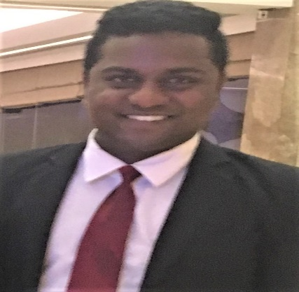
NOHA PAUL
Address: Ras al khor. Al samari residence.
Building number 18, Flat number 122.
DUBAI.
Contact No: +971 58 148 2367
Email Id: noha.paul28@gmail.com
Career Objective
I would like to spend each and every moment of my time to work hard and to fulfil all my duties and responsibilities which are given to me, positive and self-motivated professional. Possessing comprehensive background in star hotels experience in various Hospitality assignments. Courteous service professional with a strong dedication to exceeding expectations.
Educational Qualification
- Passed 10 Examinations from Karnataka Board from Basel Mission English Medium School Hubli (INDIA)
- Passed PUC II from St. Michael’s College Dharwad University in the Field of Commerce (INDIA).
- Completed B.B.A. Specialization in Marketing from Oxford College Hubli, From Karnataka University (INDIA).
Work Experience in Hotel Industry
- Worked in Denissons Hotel as a Duty Manager – (Unit of: DRN Hospitalities Pvt Ltd) Hubli-580030, Karnataka India from 03/01/2016 till 15/04/2022.
- Worked in TAJ HOTELS The Gateway Hotel Lakeside Hubli from 14/02/2013 as a Front Office Executive till 10/07/2015.
- Worked in Naveen Hotel Hubli from 04/05/2011 in the Front Office department as a Front Office Executive till 12/02/2013
- During my three years of education, I have taken part in many events and promotional activities related to hotels and brands.

Skills
- I have worked in Amedus, Fidelio, IDS and WINHMS.
- Ability to manage multiple staff in a positive manner.
- Able to provide excellent customer and personalized service including recognizing needs, complaints resolution and achievement of quality service standards.
- Goal – Oriented Focus.
- Dependable and reliable in supporting and enabling team effort.
- Earned customer admiration & respect by providing accurate information, up-to-date & timely information.
- Willingness to Learn.
- Excellent Communication Skills.

Duty and Responsibility
- Exceptionally good in Team Building and coordinating.
- Remarkable front desk Receptionist and guest service experience.
- Performing all check-in and check-out tasks.
- Expertise in handling cash and accounting machines.
- Ability to meet the requirements of a demanding guest.
- Managing online and phone reservations
- Ability to maintain a work area equipped with all professional requirements.
- Proficient with Microsoft Word, Excel, Outlook
- Co-coordinating with the entire Department.
- Following up with the signed contracts, advance payments, rooming lists, arrival and departure of the guest, guest preferences as well as handling billing letters and vouchers and update the same on the system.
- Prepare reports which reflect the past, future and present group bookings, expected VIP guests
- Loading rates that are applicable for travel agents
- OTA management
- Respond to and follow up sales enquiries using appropriate methods.
- Follow up the Outstanding.
- Experience in solving service issues and providing satisfactory service to the guests.
- Exceptionally good communication and presentation skills.
- Respond quickly to guest’s requests in Friendly manner.
- Taking Care of repeat guests according to their preferences.
- Handling shifts alone.
- Ensuring timely and accurate customer service.
- Handle complaints and specific costumer request
- Troubleshoot in emergency
- Night auditing
Achievements
• Promoted to Duty Manager
• Secured best employee award in the year 2017
• Managed the hotel named "best in customer satisfaction"

Personal Information

Fathers Name: Edwin Paul
DOB: 28/07/1988
Nationality: Indian
Sex: Male
Marital Status: Married
Language: English, Hindi & Kannada.
Passport No: T4558748 Date of Expiry: 10/04/2029
Visa Status: Visit Visa Date of Expiry: July 2022

DECLARATION: -I hereby declare that all the information given above is true and correct to the best of my knowledge. All the information shared in the resume is correct, and I take full responsibility for its correctness. I solemnly declare that the information in this resume is true to the best of my knowledge and belief.

