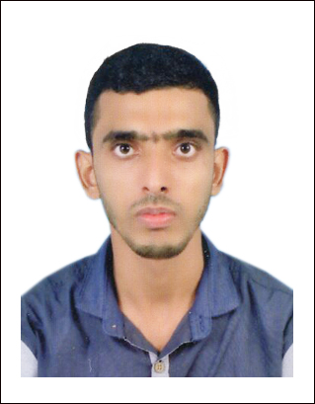
AFSAL PUTHUKKOTT KANDY
+971 55 4684142

+971 55 4684142
afsalputhukkottkandy@gmail.com
Dubai, UAE

CAREER Objective

To occupy a position dynamic and willingness to enjoy challenges of new obligation. Task or assignment and exercise persuasive communication and motivational skills in general services.
WORK Experience

- MINA AL ARAB SUPERMARKET (8 Years)
Sales Man
Dubai & Ras Al Khaimah, UAE.

- ALANKAR SUPERMARKET (2 years)
Sales Man
Kerala, India.

ATTRIBUTES

- Highly motivated strong work ethics reliable responsible and punctual. Ability to work successfully in a team environment. Having good communication skills open to challenging and creative project.
EDUCATION

- Bachelor Degree
- Higher secondary
- SSLC
India.

COMPUTER SKILLS

- DCA
- MS Office

PERSONAL Details

Name : Afsal Puthukkott Kandy
Father name : Abdu Rahiman
Date of Birth : 7th March 1989
Place of Birth : Nadapuram, Kerala
Nationality : Indian
Passport No : S0117542
Issue Date : 6th March 2018
Expiry Date : 5th March 2028
Marital Status : Single
Sex : Male
Visa Status : employment

Languages

English
Arabic
Hindi
Tamil
Personal Activation

- Hard working and self motivating.
- Strong communication and interaction skills.
- Maintain, observe honesty and safety.
- Cooperate, efficient and flexible.

Declaration

I hereby declare that the above mentioned information is true to the best of my knowledge and belief. I would take this opportunity to thank you for going through my resume and would request you to consider me to be a part of your prestigious organization.

Afsal puthukkottu kandy

