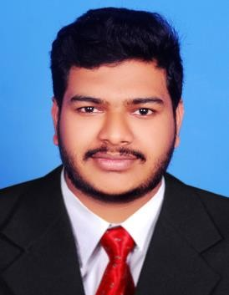CURRICULUM VITAE
MUHAMMAD THOUSEEF
Home : +971-50 427 9971
Email : thouseefmudakkal@gmail.com

OBJECTIVE

To be able to join a company where I can contribute all my knowledge and skills and be a part of an organization that provides avenues for growth and development, in line with my goal succeed as an individual.

PERSONAL INFORMATION

- Name : Muhammad Thouseef
- Father’s Name : Muhammed Musthafa
- Nationality : Indian
- Gender : Male
- Date of Birth : 06-06-1997
- Marital Status : Unmarried
- License. : Uae Manual Driving license
- Permanent Address : U.A.E , Umm Al Quwain
- Languages Known :, Hindi, English ,Malayalam & Arabic

PASSPORT DETAILS

- Passport No : P6564906
- Expiry Date : 24/04/2027
- Issue Date : 25/04/2017

EDUCATIONAL QUALIFICATION

  - Degree : B com Travel & Tourism Management , Kerala University
➢ +2 Travel & Tourism: Kerala Board of Vocational Higher Secondary Examination
  - SSLC : Kerala Board of Public Examination
SKILLS AND STRATEGIES

- Able to work co-operatively in a team environment or independently, with a minimum level of supervision
- Able to work in co-ordination with the department to ensure efficiency and output.

EMPLOYMENT EXPERIENCE

- 2 Years’ Experience as Office boy in U.A.E
- 1 Year Experience F & B Service at Hotel Orion Beach Resort. Kovalam
- Kerala ,India.
- Experience as Sales Representative Kerala, India.

DECLARATION

I Muhammad Thouseef do declare and accept that whatever-information provided in this Bio-data are true the best of my information and knowledge.

Place : U.A.E
Date : MUHAMMAD THOUSEEF

