CURRICULUM VITAE
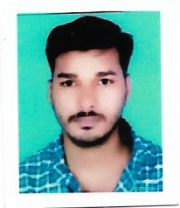

MUHAMMED P I
MOB NO:- +91 9207237919,
Email : muhammedmubi3064@gmail.com
POSITION DESIRED: ELECTRICAL ENGINEERING & DRIVER

CAREER OBJECTIVE
To grab an opportunity in a growing origination were I can apply my knowledge and expertise to the advantage of the organization that employs me, which would also promote my grasp of the domain. As a continuous learner of success of the corporate I serve

Personal Details
Name : MUHAMMED P I
Age : 32
Date of Birth : 01/01/1990
Gender : Male
Father’s name : ISMAIL
Marital status : Married
Nationality : Indian
Religion & Caste : Muslim

Languages Known : English, Malayalam, Arabic & hindi

EDUCATIONAL ATTAINMENT
- Secondary school
- Higher secondary
PROFESSIONAL QUALIFICATION
• Electrical engineering
DRIVING LICENSE DETAILS
LICENSE NO : 58/17874/2017
FIRST ISSUE : 30/12/2017
VALIDITY : 29/12/3037

PASSPORT DETAILS
Passport No : T9988267
Place of Issue : Kozhikode
Date of Issue : 19/11/2019
Date of Expiry : 18/11/2029
WORKING EXPERIENCE
- 7 YEARS EXPERIENCE IN ELECTRICIAN ASSISTANT IN SAUDI ARABIA .
- 10YEARS EXPERINCE AS DRIVER IN INDIA.

Declaration:
I hereby declare that the above furnished information is true, to the best and true of my knowledge and belief.

Place :- ADAKKATHODE
Date :-
Name and signature

MUHAMMED P I

