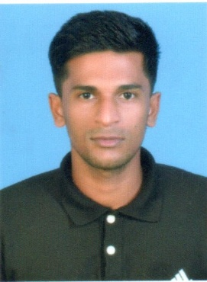
SINANA KHAN A
9747832076

JOB OBJECTIVE

Looking for a competitive and challenging position in a highly growth oriented organization where my knowledge and experience can be effective put to use for the betterment of organization.

Applicable Skills:
- Office clerk
- Fire watchmen
- Safety officer trainee
- Asst Storekeeper
- Office boy
- Kitchen helper
Education & Training:
- +2 Science, Kerala higher secondary Examination board 2012
- SSLC , Kerala higher secondary Examination board 2010
- Diploma in Computer Application (DCA) 2012
- Diploma in fire & Safety
- Advance course in food production and beverage ( 6 month )
- Skill training completed in food production and beverage from Leela ravis hotel kovalam.
LANGUAGES;
- MALAYALAM /TAMIL / HINDI / ENGLISH
Work Experience:
- Kichen helper in food and bevarage department at Neelakanta beach resort Kovalam. from August 2017 to July 2019.
- Vegetable Cutter in food and beverage department at keerthi hotel trivandrum from August 2019 to Continue.

PERSONAL DETAILS:
Name: SINANA KHAN A
Father’s Name: M. ABDUL SALAM
Sex: Male
Age: 23
Date of Birth: 27/09/1995.
Religion: Islam
Passport No: R 6000194
Marital Status: Single
Nationality: India
Address: Thaikkoottam Purayidam harbor Road vizhinjam
Trivandrum Kerala,
Email address: sinankhan432@gmail.com
Declaration
I hereby State that the information furnished above is true to the best of my knowledge and belief.
SINANA KHAN

