RESUME

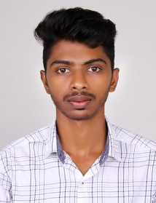
MOHAMMED HANEES M T
MOOKACHARUTHODI HO
VENGAD, MALAPPURAM
679338 ,KERALA
MOB & WATSAP NO:9846345245
Email id: haneesmtm@gmail.com

CAREER OBJECTIVE

Seeking suitable position with substantial responsibility where my varied knowledge would be fully utilized and where I could make significant contribution to my employer which will gain me career advancement opportunities.

PERSONAL DETAILS
Father’sName : MOHAMMED ALI
Dateof Birth : 22/03/1998
Sex : Male
Nationality : Indian
Religion : Muslim
MaritalStatus : Single
LanguagesKnown : English , Malayalam,Hindi

QUALIFICATION
Academic : S S LC
PLUSTWO
Diploma in mechanicalengineering
Experience : Three months internalship experience as in HMTmechine tools ltd,Kalamassery
Three monthsinternalship experience as in Tafe Tractor Manufacturing company Banglore

DECLARATION
I hereby declare that the above mentioned information’s are correct and complete to the best of my knowledge and belief.

Place: VENGAD
Date: MOHAMMED HANEES M T

