RESUME
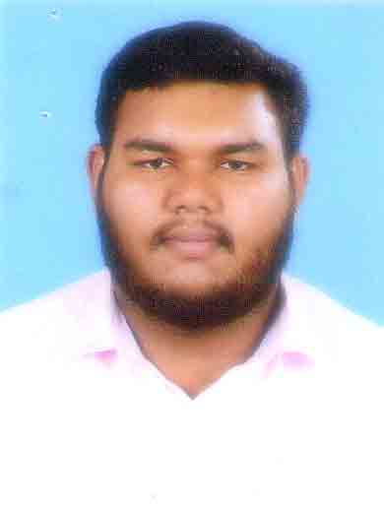
MUHAMMED SHAMEEM M
Mob: 9567603461
Email: shameemmukri313@gmail.com

CAREER OBJECTIVES
Seeking a job in a challenging and competitive environment with a strong attitude work coupled with honesty and will to achieve to become a part of management in a dynamic organization.
SKILL SETS
- Good interpersonal skills
- Excellent communication skills
- Good analytical & problem solving skills.
EDUCATION QUALIFICATION
- Plus two from Board of Higher secondary examination, Kerala
- SSLC from Kerala Public Examination.
TECHNICAL SKILLS
- MS Office, Tally
HOBBIES
- Driving
- Reading
STRENGTH
- Sincere & honest
- Hardworking
- Planning and Problem solving skill
- Leadership quality

PERSONAL DETAILS
Date of birth : 12/08/1997
Nationality : Indian
Language known : English, Malayalam, Hindi
Address : T K P House, Thayineri
Payyanur PO
Kannur- 670307

PASSPORT DETAILS
Passport Number : R 4217892
Date of issue : 30-11-2017
Date of expiry : 29-11-2027
Place of issue : Kozhikode

DECLARATION
I hereby declare that all the information furnished above are true and correct to the best of my knowledge and belief.
Place: MUHAMMED SHAMEEM M
Date:

