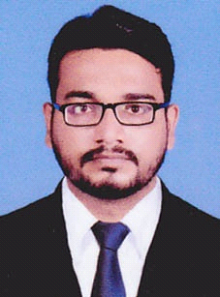
RASHEED K
Email ID- rasheedpadanakad2@gmail.com
Contact No. 0582720643

Career Objective
Highly managerial skills want to implement for organizational growth and it should also provide me financial stability.
Career Summary
- A detail oriented and highly skilled in manage the things possesses rich experience of 1 year as Sales Officer
- Proficient in managing the documents.
- Excellent in providing comprehensive secretarial and administrative support to colleagues
- Proficient in executing the programs using the limited resources.
- Expert in assisting the seniors and manage the routine daily organization life.
Personality Traits
- An enthusiastic person who performs all office tasks to the highest standard and within given timescales.
- Excellent communication skills in written and verbal both.
- Proven electronic diary management skills.
- Good telephone manner and client interface skills
Education Knowledge
- SSLC ( Board Of Examination Kerala)
- PLUS TWO
- BSC (STATISTICS)

Computer Knowledge
- Proficient In Basic Use Of Computer
- MS Office (MS Word, MS Excel, Power Point )
- Internet
Key Responsibilities Handled
- Responsible for all aspects of the day to day running of the filing, copying, report
writing, and invoicing jobs.
- Responsible to handle the telephone enquiries
- Manage the documents in proper way.
- Handle all the other responsibilities related to the job.

Achievements
- Get appreciation many times for the quality services.
- Create a unique way to manage the documents.
Working Experience
- Worked as an Sales Officer in MARUTHI SUZUKI, POPULAR VEHICLES AND SERVICES LTD. in Kerala during the period 2014 to 2016
- Worked as an sales officer in IDBI BANK, KANHANGAD in kerala during the period 2016 to 2018
- Worked as an sales officer in COCA COLA in kerala during the period 2018 to 2020
Personal Details
Name : Rasheed K
Date Of Birth : 24/02/1990
Gender : Male
Marital Status : Single
Nationality : Indian
Religion : Muslim
Languages Known : Hindi, English, Malayalam
Passport No. : V2214349
Address : Rasid Manzil,Karuvalam, Padannkad P O
Declaration
I hereby declare that the above mentioned details furnished by me are true and correct to the best of my knowledge and belief

