CURRICULAM VITAE 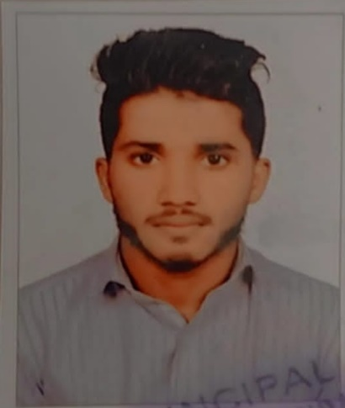
MUHAMMED RASSAL S
SAIDHARAKATH HOUSE
RIYAS MANZIL
KURUVAPALAM
P O KADALAYI
670007
7909216457
rajulaksana09@gmail.com
personal details
Father’s name : Riyas p
Mother’s name : Khayarunnisa S
Date of birth : 5/11/1998
Sex : Male
Religion : Muslim
Nationality : Indian
Marital status : Single
Passport No : RO782916
(date of expiry : 4/09/2027)
Licence No : C1236867
LANGUAGES KNOWN
- Malayalam
- English
ACADEMIC QUALIFICATIONS
- SSLC
- PLUS TWO

STRENGTHS
- Hard working
- Responsible
- Time management
- Communication skill

EXPERIENCE
- Two year experience in sales department from Nikshan electronics
- Two year experience in filling boy in petrol pump
career objective
To start my career with an organization that will utilize my most supervision& administration skills to benefit mutual growth & success

