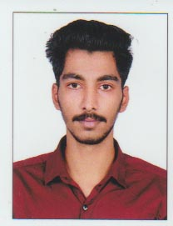
SUBIN.S
Subin Bhavanam
Thekkemuri
East Kallada-PO
Pin:691501
Kollam, Kerala Mob:9746753518, Email:subinskallada@gmail.com

Objective
Looking for good career that created on the basic of my knowledge, skill, Maximum efficiency and high responsibility in this field.

Personal information
Father’s Name : Sajimon
Date of Birth : 22/07/1999
Caste : Christian
Marital Status : Unmarried
Nationality : India
Languages Known
English & Malayalam
Educational Qualification
- S.S.L.C Passed from Board of Public Examination, Kerala
- Plus Two (VHSE. MRA) Passed from Kerala
Technical Qualification
- Diploma in Electrical Engineering one year
Experience
- Two year experience as Electrical and Plumbing works.

Declaration
I Certify that the above information made is true to my good faith.

Place: East Kallada SUBIN.S
Date :

