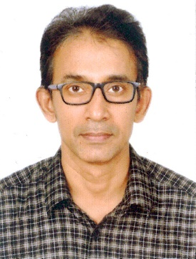
ASHARAF ILLIKKAL
WAREHOUSE MANAGER, DATA ENTRY OPERATOR
Experienced with over 15 year of experience in service center. Excellent reputation for resolving problem, improving customer satisfaction, and driving overall operational improvement. Consistently saved costs while increasing profits. Multi-talented consistently rewarded for success in planning and operational improvements. Experience in policy development and staff management procedures positively impacting overall morale and productivity.
WORK HISTORY
2006 - 2020 Warehouse manager
PLAZA AIR CONDITIONING REFRIGERATION & ENGINEERING, DOHA, QATAR
- Collect and arranged financial information and entered details into SAP financial management system.
- Identified and investigated variances to financial plans and forecasts.
- Completed daily cash functions like account tracking , payroll and wage allocations , budgeting , donating and all type of cash and banking reconciliation
EDUCATIONAL QUALIFIACTION
1989 - 1990 SECONDRY SCHOOL LEAVING CERTIFICATE (SSLC)
Azhikode High School - Azhikode, Kannur
1992 - 1993 Pre-degree
Calicut University - SIR SYED COLLEAGE TALIPARAMABA
1991 Typewriting English
Government of Kerala - Government technical examination
1997 DIPLOMA COMPUTERISED OFFICE MANAGEMENT
MMCC PAPPINISSERI
SKILLS
- Patient –focused quality service
- Data warehouse maintenance EWMS
- Warehouse safety
- Service agreement information
- Customer service experience SAP software
- Warehouse training EWMS
- Invoicing and collection, data processing, expenses report, book keeping
- Month –end report, file and data base management

LANGUAGES : English, Hindi, Malayalam,

SOFTWARE : SAP EXPERIENCE

CONTACT DETAILS
ADDRESS : AFNAS, AZHIKODE P.O. KANNUR-670009
PHONE : 00971 0586695831
E- MAIL ID : asharaf2293@gmail.com

PASSPORT DETAILS
NAME : ASHARAF ILLIKKAL
PASSPORT NO. : U0734280
ISSUE PLACE : DOHA
ISSUE DATE : 18-11-2019
EXPIRY DATE : 17-11-2029

