CURRICULUM VITAE
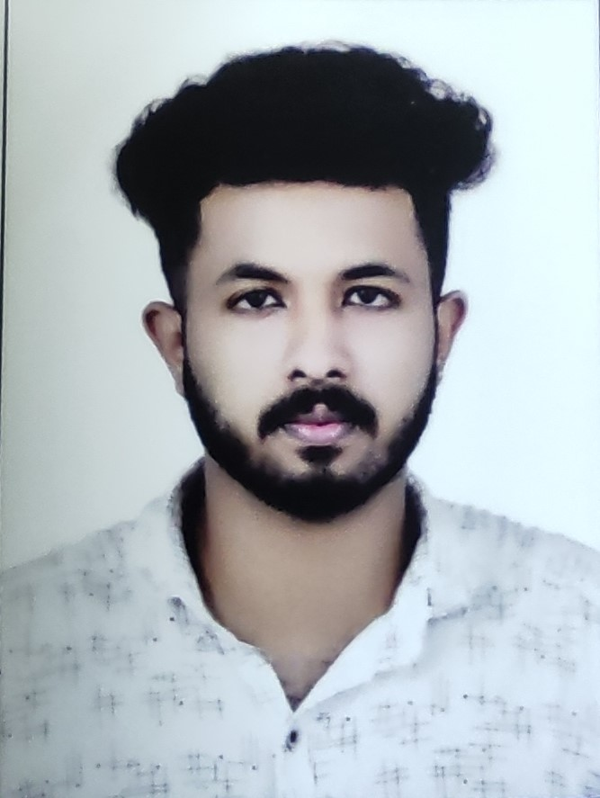
SUMITH S
S S NIVAS
MISSIONKUNNU
NILAMEL P O
KOLLAM(DIST)
KERALA
PIN 691535
PERSONAL DETAILS
DATE OF BIRTH : 05/07/2000
NATIONALITY : INDIAN
Sex : MALE
Marital Status : SINGLE
NAME OF FATHER : SURESH BABU
NAME MOTHER : SUMI
RELIGION AND CASTE : HINDU, EZHAVA
LANGUAGE KNOWN : MALAYALAM , ENGLISH, HINDI
MOBILE NO : 058283158
Email : sumithkdl8@gmail.com
EDUCATIONAL QUALIFICATION
SSLC
PLUS TWO ( HUMANITIES)
ITI (AUTOMOBILE)
PERSONAL SKILLS
GOOD ABILITY TO UNDERSTAND EVERYTHING QUICKLY
GOOD KNOWLEDGE ABOUT COMPUTER
GOOD COMMUNICATION SKILL
LICENCE DETAILS
LICENCE NO : KL 24 20190017396
DATE OF ISSUE : 29/06/2019
DATE OF VALIDITY : 28/06/2039
CLASS OF VEHICLE : MCW,LMV
PASSPORT DETAILS
PASSPORT NO : V8789586
DATE OF ISSUE : 08/04/2022
DATE OF EXPIRY : 07/04/2032
DECLARATION
I here that declared all details and informations are true and correct best of my knowledge.

Place: Missionkunnu
Date: Sumith s

