CURRICULUM VITAE
Career Summary:
My career objective is to have the opportunity to attain a challenging position in your organization, so that I can utilize my knowledge to grow develop and advance within your organization to accomplish over all corporate goals and objectives.

EBRAHIM HAFNIYASH
Deira, Dubai

Mob: +97 1 523734077
ihafniyaz@gmail.com

Personal Data
Father’s Name : Muhammed
Date of birth : 22-05-1995
Sex : Male
Nationality : Indian
Religion : Islam

Languages Known
- Arabic
- English
- Hindi
- Malayalam

Passport Details
Passport No. : N0785538
Date of Expire : 16-07-2025

Visa Status: Tourist visa
Date of Expire: 28-08-2022

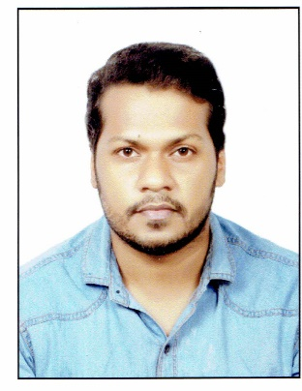

EDUCATONAL QALIFICATIONS

- Completed Higher Secondary Education in Humanities group from Kerala State Board (2016)
- Completed High School Education by Kerala State Board (2014)

WORK EXPERIENCE

- 2 ½ year well working experience at Baskin Robins in Saudi Arabia
- 1 year working as a salesman at Venture fashions Kerala India
- 2 year working in Food Corner Restaurant Kerala India

SKILLS

- Good Communication Skills
- Relationship building skills
- Optimistic & Positive Attitude
- Customer Service
- Reliability
- Positive attitude
DECLARATION
I hereby declare that the above given particulars are true to best of my knowledge and belief.
EBRAHIM HAFNIYASH

