CURRICULUM VITAE

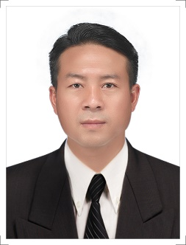
Contact Information:
Email : kodede.alex@gmail.com
Mobile : (WhatApp +959790426821)
Address : Burjman or Alfahedi metro station exit 4
Bank Stree, almaya super market same building
Bur Dubai,UAE.

Personal Info:
Name : MR. ALEXANDER DE DE
Date of Birth : 25- 06- 1984
Father’s Name : U Maung Than
N.R.C No : 2/pha ya sah (N)012651
Race : Kayah
Religion : Christian R.C
Sex : Male
Marital Status : Single
UAE Tourist Visa Valid till 18th April 2022

Objective : Currently looking for new direction and challenges. Seeking to continue my personal skills in new area. Ready to explore my skills and abilities for new organization. Excited to learn new things to grow in professional life.
Interests:
- Team Work
- Customer Service
- Music
- Hospitality

Education:
- High School Diploma in Loikaw, Kayah State, Myanmar
- Graduated in Psychology Distant Education in Loikaw University, Kayah State Myanmar
- Certificate of Best in English in 6 Months Course of YLFC – Youth Life Formation Center (English Grammar, Basic Microsoft Office Word, Management, Leadership Skill, Music, Sports)
- Certificate of Best Leadership award in 6 Months Course of YLFC
Work Experiences:
- Receptionist in Mingarlar Hotel – 1 Year
- Waiter Position in Local Restaurant – 1 Year
Strength:
- Honest
- Patient
- Punctual
- Hardworking
Interest:
- Reading
- Listening Music
- Sports

