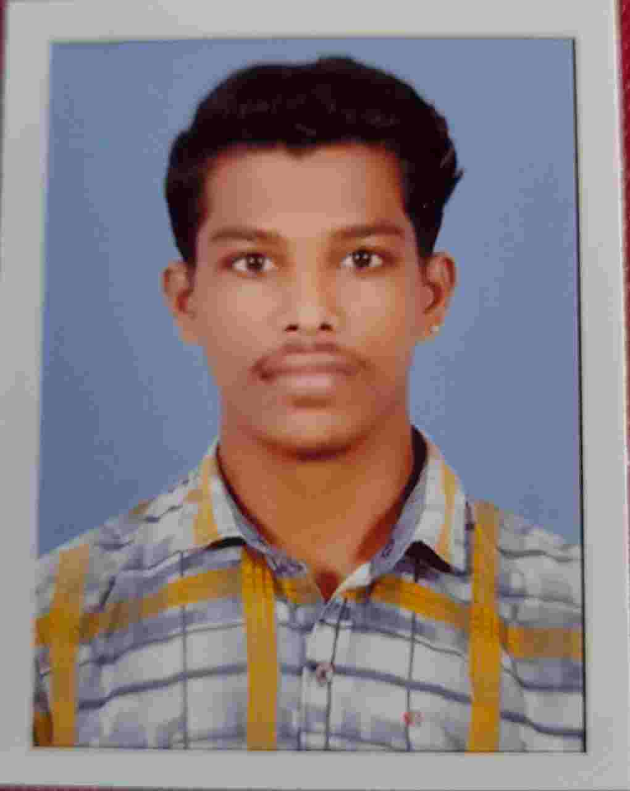
HARIPRASAD S
Contact No. 7594811987
Email: hariprasad1998kolathur@gmail.com

OBJECTIVE
To work with an organization that provides me an opportunity to grow as a
Professional as well as an individual and were my potentials can completely
Utilized to serve the organizational goal.

ACADAMIC PROFILE

Program | Institution | Marks | Year of Completion
ITI [Electrical  Engineering | All India Technical Education  Society Thrissur | First  Division | 2018
Prak-Shastri (Intermediate) with Teacher Training Course | Central Sanskrit University New Delhi | Second Division | 2016
Class X | Kerala State Board | 65% | 2015

EXPERIENCE

* INFRA ELAVATORS - CHERTHALA KERALA
Technician (Maintenance and services)
Period: 6 months

* CONE ELAVATORS – MUMBAI
Installation works – period: 1 year experience

* Computer billing – Supermarket Ernakulam
Period: 2 year experience

* Waiter - Calicut (Drunken monkey Restaurant)
Period : 1 year

* Extra Curricular Activities
Two- Wheeler Driving
Electrical works

* Pass port number : T 8490718

PERSONAL INFORMATION
Name | Hariprasad s
Date of Birth | 07/08/1998
Marital Status | Unmarried
Nationality | Indian
Religion | Hindu
Address | Sree Sankara balasadanam, Kolathur (PO), Atholi (via) Kozhikode 673315
Language known | Malayalam, Sanskrit, Tamil, English, Hindi

