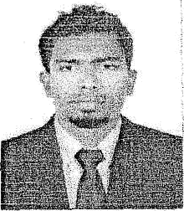

FARIS KHAN A

JOB OBJECTIVE

Looking for a competitive and challenging position in a highly growth oriented organization where my knowledge and experience can be effective put to use for the betterment of organization.

Applicable Skills:

- Office clerk
- Waiter
- Asst Storekeeper
- Office boy
- Sales manager

Education & Training:

• +2 Science, Kerala higher secondary Examination board 2011
- SSLC , Kerala higher secondary Examination board 2009
- Advance course in food production and beverage

LANGUAGES;
  - MALAYALAM/TAMIL/ HINDI /ENGLISH/ARAB1C/DHIVEHY

Work Experience:

  - Waiter in The Neelakanta Beach Resort Kovalam From 01 April 2016 to 31 March 2018

PERSONAL DETAILS:

Name
Father’s Name

Sex
Age
Date of Birth Phone Religion Passport No Marital Status Nationality Address

Email address
FARIS KHAN A ABDUL RAHIM
Male 25
18/02/1994

8136958898
Islam & Muslim
K 7822023

Single INDIAN

TOWNSHIP COLONY
VIZHINJAM

VIZHINJAM P 0 695521 TRIVANDRUM KERALA
: farisfriends28@gmail.com

Declaration
I hereby State that the information furnished above is true to the
best of my knowledge and belief.

FARIS KHAN A

