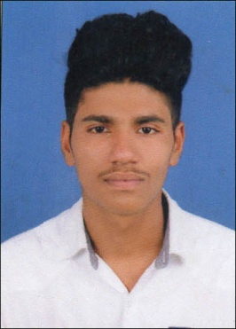
CURRICULAM VITA
RAHUL K P
Pariyangalath - House
Ekarool - Po
Unnikulam Via – 673574
Email : rahulrz847@gmail.com
Mob : 9656876869 , 9567721789

Personal Details
Father Name : Rajan K P
Date of Birth : 13.07.2000
Gender : Male
Marital status : Single
Religion & Caste : Hindu , Asari
Nationality : Indian
Language Known : English , Malayalam & Hindi

Education Qualificatio
EDUCATIONAL QUALIFICATIONS

QUALIFICATION | YEAR OF PASSING | INSTITUTION
SSLC | MARCH 2015 | M J H S S ELETTIL
PLUS TWO | MARCH 2017 | GVHSS THAMARASSERY
ITI ( Carpentry) | JULY 2018 | GOVT. ITI MALIKADAVU
MACHINE OPERATER INJECTION MOULDING | SEPTEMBER 2019 | CIPET IPT KOCHI

DECLARATION
I hereby declare that the details furnished above are true to the best of my knowledge and belief.

Place : Ekarool RAHUL K P
Date :

