BIO-DATA

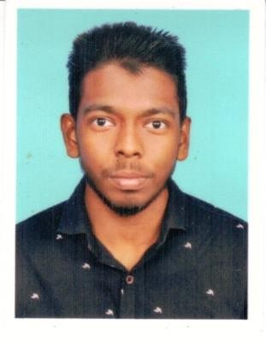
JIYAD M
Mundasseru Mammattamchola (H) Vazhakkad (PO)
Malappuram-673640 Kerala
India
E-mail:www.jiyad9744828206@gmail.com Mob: +91 9744828206

PERSONAL PROFILE
- Date of Birth : 13/07/2002
- Father’s Name : Abdul Kareem M
- Religion : Islam, Muslim
- Nationality : Indian
- Marital Status : Single
- Sex : Male
- Languages Known : English, Arabic & Malayalam

EDUCATIONAL QUALIFICATION
- SSLC : Kerala Board of Public Examination

PASSPORT DETAILS
- Passport No. : U9946290
- Place of Issue : Kozhikode
- Date of Issue : 14/06/2021
- Expiry Date : 13/06/2031

WORK EXPERIENCE
- Worked as a salesman – SUPERMARKET MC MALL EDAVANNAPPARA, KERALA, INDIA (from 2019-2022)

SKILLS
- Creativity
- Communications
- Positive Attitude
- Decision Making
.

DECLARATION
I hereby declare that all the above furnished details are true and correct to the best of my knowledge and belief

Place: UMM AL QUWAIN
AJMAN, UAE JIYAD M
Date : 06/03/2022

