ABDUL LATHEEF 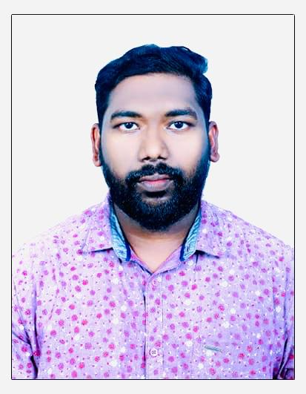
Mob:+91 9746923966
E-mail:latheefpullani@gmail.com

Objective
Towork with a professionally managed organization, with career development opportunity where I can deliver the best of my abilities

Profilein brief

- Good knowledge in MS Office & Accounting Package- Tally
- Good communication skill / Experience in Data Entry operation
- Tactful and excellent in Public Relation & Customer Service.
- Dedicated, hardworking and pleasing mannered.

Work Experience

1.Accountant
Company :QRS Retail LTD
Location : Malappuram
Duration : 2011 to 2012
2.Accountant
Company : QUALITY RETAIL GROUP
Location : Doha-Qatar
Duration : December 2012 to June 2018
3. Accountant & Salesman
Company : Mr Tiles
Location : Kottakkal
Duration : March 2019 to Still Continue..
Job Responsibilities
- Responsible for the overall timeliness, accuracy and reporting of the Company's financial results.
- Manual & computerized accounting up to finalization and monthly yearly trial balance.
- Maintenance of monthly cash flow & cash/ cheque payment to Creditors.
- Reconciliation of monthly bank statements.
- Preparing monthly report for the Management.
- Finalization of Balance Sheet, Expense Report of the Employees,preparation of finance reports, cash flow.
- Maintaining books of accounts, such as Debtors, creditors, entry etc.
- Preparing various reports required by the Auditors
- Ability to work under pressure.
- MIS Reporting and providing guidelines to Top Managers for their Decision making process.
- Purchase order and documents controlling.

Proficiency

Accounting Packages: Tally ERP9.
Others : MS Excel, MS Office,

Education
Qualification | Year | University
I P A | 2012 | Professional Accountant
B.Com | 2011 | Periyar University
Plus Two | 2008 | Board of Secondary Examination

Strength and Interests
Self confidence, hard work, Coordination ability, diligence at work, optimistic, willingness to learn, team facilitator, leadership ability and Event Management

Personal Details

Name : Abdul Latheef
Date of Birth : 30/10/1988
Father’s Name : Kunhi Mohammed
Nationality : Indian
Gender : Male
E-mail : Latheefpullani@gmail.com
Languages : English,Malayalam& Hindi

Passport Details
Passport No : U9867177
Place of Issue : Malappuram
Date of Expiry : 19-04-2031

Declaration

I hereby declare that the information cited above is true to the best of my knowledge and belief.

Abdul Latheef

