RESUME
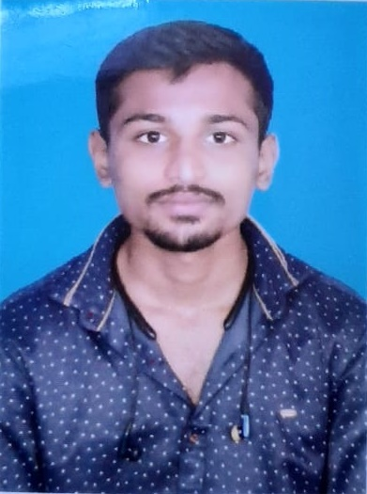  SABEETH K A  E-mail: sabithpoul@gmail.com  Mobile: +919741102033  COMMUNICATION ADDRESS:  SABEETH K A  S/0 Abdul lathif K M  MUMBAL near anandapura  sagara (tq)  shivmoga (dist)  Pin 577201  karnataka  PERSONAL DATA:  Father’s Name : Abdul lathif K M  Date of Birth : 10-12-1996  Sex : Male  Nationality : Indian  Marital Status: Unmarried  Linguistic proficiency:  English  Kannada &  Hindi  Malyalam,tamil  Permanent Address:  SABEETH K A  S/0 Abdul lathif K M  MUMBAL near anandapura  sagara (tq)  shivmoga (dist)  Pin 577201  karnataka | Career Objective  An opportunity to work in a vibrant and exciting environment that hones my skills and to contribute positively towards the growth and prosperity of the company and also to secure a position in this ever expanding field by virtue of my sincerity and dedication  Skill Sets  My Strengths: Good communication, team worker, hard working, fast learning and analysis, Urge to learn, Being Practical rather than theoretical, Ability to adopt to People and work in team, Positive Attitude  Believe In : Team work, Quality, Result oriented, Honesty  Academic Record:  Academic project details:  Title:- “performance of district industrial centers in industrial development”  Specialization:  ACCOUNTS  EXPERIENCE:  - 2 years Experience in accounts maintaining and work as a supervisor in MSC Pvt ltd  - 6months experience in resource excutive in agricultural department at Ninja Cart.  - 6months sails experience as sales executive at Star Flush in Pipe Sector.  - Prsently working in Bharath Finance ( Indusind bank ) as BSS Loan officer.  Conference & seminars:  participated:  - One day seminar on  “Financial & marketing management”.  - Two day workshop on “Learning and Life Skills Training”.  -certificate of NIOS,BFSI,NSBC,NITD,NCMES  Computer skill.  CTTC: MS-office, Tally , C, DOS, FCC, Windows.  Hobbies  Playing chess and cricket and making new good friends  Declaration:  I hereby declare that the above-furnished information is correct and I am responsible for its accuracy.  Place:  Date: (SABEETH K A)
  COURSE | COLLEGE/UNIVERSITY | YEAR OF PASSING | PERCENTAGE  OF  MARKS
  SSLC | KARNATAKA BOARD. | 2011 | 48.48%
  P.U.C | GOVT PU COLLEGE HOSADURGA | 2013 | 51.66%
  B.COM | DAVANAGERE UNIVERSITY | 2021 | 50.85%

