RAMSIYA FARESH

Pukkumadathil House , Chelakode , Thrissur
ramsiyamn@gmail.com
9446925963 , 9562198538

JOB OBJECTIVE

In quest of challenging middle level assignments for providing expertise gained in Financial Reporting / Auditing / Accounting with a growth-oriented organisation to ensure the top line profitability through optimum utilisation of resources in Banking / Financial Services sector .

PROFILE SUMMARY

- CA intermediate with 3 years of training in Auditing, Finance & Accounts
- Skilled in handling finance & accounts activities encompassing finalization of accounts, fund arrangement, tax planning & settlement of payments in close coordination with stakeholders (internal & external)
- Proficient in conducting financial analysis, preparing key reports and implementing systems & procedures to ensure operational effectiveness; adept in exercising internal control for profit analysis & working capital management
- Adroit in presenting true & fair view on financial position of the organization by timely preparing financial reports to analyse the expenditure on a regular basis
- Possess strong interpersonal, presentation &analytical skills with ability to resolve issues for peak performance

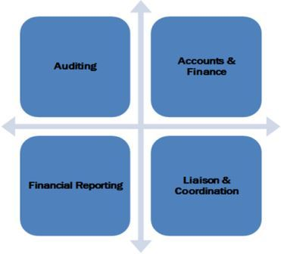 | 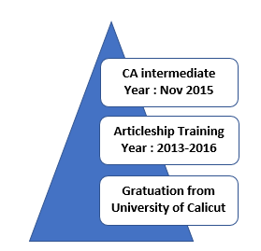

CORE COMPETENCIES

- Attending & conducting operational, managerial, statutory, concurrent & internal audits, evaluating financial control systems with a view to highlight shortcomings and incorporating recommendations of Auditors as per standard norms
- Generating reports to provide feedback to top management on financial performance viz. analysis of profit, sales, costs, material consumption, inventory, creditors, debtors& overheads
- Monitoring cash flow by taking adequate measures for optimum utilisation of available funds; developing framework on the basis of tax assessment & liability through acceptable levels of residual risk
- Consolidating the audits reports in compliance with accounting standards & policies; performing key role in validating business plans to maximise profitability & revenue generation as per corporate goals
- Computing & arranging the timely deposit of taxes (Indirect, Service, Income, Wealth, Professional & Direct Taxes) and filing returns to ensure timely completion of assessment as per statutory norms

ORGANISATIONAL EXPERIENCE
ARTICLESHIP EXPERIENCE

Aug’13-Aug’16 M/s Davy & Co Chartered Accountants, Thrissur, Kerala, India as Articled Assistant

Role:
- Preparation of audit planning and strategies.
- Verification of Financial Statements (Balance Sheet, Profit & Loss, Cash Flow and related statements and notes).
- Verification of compliance to applicable laws and regulations and reporting requirements as are applicable to organizations.
- Checked presentation and disclosure of financial statements in accordance with applicable local laws, Financial Reporting Standards .
- Reviewing preparation of budgets and their comparison with actual results. This also includes assessing going concern assumption and future viability (both financial and operational) of the company.
- Preparation of policies and procedural manuals for Fixed Assets, Auditing, HR and Procurement activities.
- Performed systems review with focus on determining the adequacy and effectiveness of key operating policies and procedures, identified
- and evaluated business risk, identified process improvements, and developed recommendations thereof.

CERTIFICATION / OTHER COURSE

- General Management & Communication Skills Program from ICAI, Thrissur, Kerala in 2013

- Orientation from ICAI, Thrissur, Kerala in 2012

TRAINING

- 100 Hrs. Computer Training from ICAI, Thrissur, Kerala in 2013

IT SKILLS

- Conversant with Tally ERP 9.0, MS Office and Internet Applications

EDUCATION

2015 CA (Inter) from ICAI, New Delhi, India
2011 B.Com Finance from NSS College, Ottapalam, Palakad affiliated to Calicut University with 68%
2008 12th from SMT Government Higher Secondary School, Thrissur, Kerala affiliated to Kerala Board with 86%
PERSONAL DETAILS

Date of Birth:16th May 1991
Languages:English and Malayalam

