Mohomad Anfas
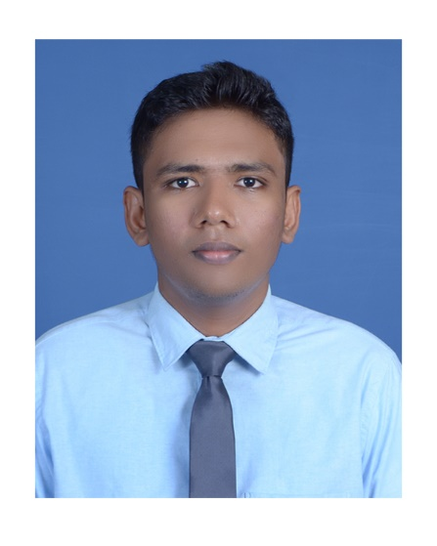

Contact

Address:
Dubai, UAE

Visa Status:
Visit Visa (valid till 4th of April)

Date of birth:
05.01.1994

Phone:
+971581658615

Email:
mohomadanfas@gmail.com

LinkedIn: linkedin.com/in/anfas-mohomad-160044200

Languages

English – Fluent Sinhala – Fluent
Tamil – Fluent

Skill Highlights

- Problem Solving
- Teamwork
- Critical Thinking
- Communication
- Time Management
- Collaboration
- Creativity
- Adaptability

Profile

Results driven professional with experience in various facets of accounting, project coordination and customer service. Extensive software proficiency covering wide variety of applications, and talent for quickly mastering technology. Enthusiastic, knowledge-hungry learner, eager to meet challenges and quickly assimilate new concepts.

Experience

- Trans Gulf Lanka

- Account and Administration officer.
December 2016 to January 2018

  - Reviewing/Preparing Financial statements based On International financial Reporting standards.
  - Reviewing Monthly closing procedures and ensure accounting treatments in line with standards.
  - Responsible for managing to receivable and creditors.
  - Treasury management. (Finance, Banking and Petty cash)
  - Reviewing the accuracy of VAT returns and other special requirements imposed by the industry.
  - Handling banking reconciliation and treasury management.

J J MOTORS GROUP

- Customer service & Sales Executive.
March 2018 to November 2021
  - Preparation of Monthly Sales reports and analyzing with the management.
  - Involved In Sales and Marketing which includes Sales KPI’s.
  - Maintaining Professional Relationships with clients and resolving problematic Issues.
  - Treasury management. (Finance, Banking and Petty cash)
  - Client management and Resolving customer complaints by escalating to relevant Departments.

Education

- Partly qualified in CIMA (Charted institute of Management Accountant)
- Passed GCE Advanced Level commerce stream (2013) Maliyadewa Model Collage, Kurunegala. Sri Lanka.

Achievements & Extra Curricular Activities

    - Having good knowledge of trading forex, Crypto currency, stocks exchange and commodities.
    - Completed Program in developing professional and employability skills.
    - Member of school football team.
    - Member of united football. F.C Polgahawela , Sri Lanka.
    - Member of school commerce society.

Referees

Reference are available on request.

I hereby confirm that above furnished particulars are true to the best of my knowledge and belief.

M.A.M Anfas.

