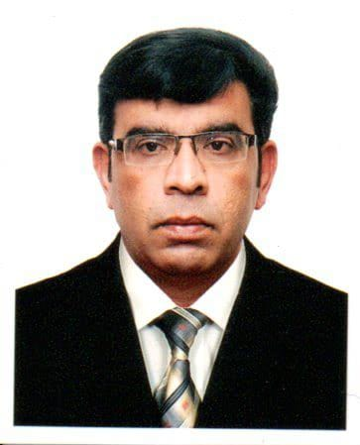
SAEED IQBAL

OBJECTIVE

To make the use of my professional abilities and qualifications to enhances my skill by working in the dynamic organizations with opportunity for growth. Enhance my performance in modern ways and throw out cramming concept

PERSONAL INFORMATION
D.O.B 06-March-1971
Marital Status Married
Religion Islam
Domicile Lahore
Nationality Pakistan
E-Mail sdrz1779@gmail.com
Contact #. 0524997688

ACADMIC QUALITFICATION:
Diploma in administration & office management

EXPERIENCE

S.C.P (U.A.E) (Receptionist & store in charge) (4yrs)
Danial-o-trd(U.A.E) (Supervisor) (4yrs)
Combine World. (PAK) (Office coordinator) (2yrs)
Hotel TC INN (MALAY) (Front desk in charge) (1 yrs)
Hibat Enterprise (MALAY) (Sales Representative) ( 2yrs)
Power Security Services ( U.A.E) ( Administrative security officer) (3 yrs)
F&H Enterprises Pvt Ltd PAK ) ( Contract Manager ) ( At Present )

( In Season Champions Preparation the responsibilities were)
Receive, direct and relay telephone messages and fax message
Maintain the general filing system and file all correspondence
Assist in the planning and preparation of meetings, conferences and
Telephone call Respond to public inquiries
Receive incoming goods
Check for damage/shortage and prepare report
Ensure all materials handling equipment are in goods condition
Supervise unloading of material Count, tally
Handling store and preparing stock, checking deliveries and purchase in and out update daily products.
Ensure that rules and regulations relating to physical custody and preservation of stores are followed

( InDanial – 0 –trd the responsibilities were )
Mainly responsible for handling and managing daily administration of the
Organization to maintain a good work environment.
Handling all the clerical duties of the organization
Responsible for responding queries of customers and solving problems

( In Combine World the responsibilities were )
Type’s agendas for meetings
Prepares meeting packages and distributes to Council Members at least two days prior to the meeting
Attends, records and transcribes minutes of all First Nation Meetings
Word processes all manuscripts, letters, documents and proposals
Records, date stamps and distributes all incoming mail Processes outgoing mail
Compiles and maintain an up to date telephone directory of numbers and addresses
Files all correspondence
Updates the bulletin board by posting and removal of outdated materials
Ensures the Administrative Offices, Reception Area and Council Chambers are kept clean

( HotelTc Inn)
Register guests and assigns rooms. Accommodates special requests whenever possible.
Assists in preregistration and blocking of rooms for reservations.
Knows room locations, types of rooms available, and room rate
Uses proper mail, package, and message handling procedures. Courier Mail Register
Maintains the cleanliness and neatness of the front desk area.
Process guest check-outs.

(Hibat Enterprise)
Serves customers by selling products and meeting customer needs.
Greet customers.
Help customers find items in the store.
Check for stock at other branches or order requested stock for customers.
Provide customers with information about items.
Ring up purchases.
Elevate complaints to management.
Keep track of inventory.

( Power Security Services)
Under direct supervision perfoms daily office clerical task such as filling,recordings.
Maintain records,copying,posting and other similar duties.
Answering phones direct calls and takingmsgs.
Maintain moderately indexes fillings
Monitor and authorize entrance and departure of employees, visitors. And
Other person to guard against theft maintain security of premises.
Screen individuals and prevent passage of prohibited articles in to restricted areas.
Patrol offices, facilities and maintain the security in all areas

F&H Enterprises pvt ltd
Create n maintain relationship with suppliers n serve as the singular point of contact for matters concerning contractd.
Commumicate n present information to stake holders about all contract related matters
Solve any contract related problems that may arise with other parties n internally with the company itself.
Maintain records for correspondence n documentation in relation to established contracts n those in progress

LANGUAGES

- URDU
- English
- PUNJABI

SKILLS

- Microsoft Office, Excel MS word, Net Browsing
- Achieved Award in Security officer(STATIC & PATROL)UK.
- Achieved Award in Securityofficer (DPS) Dubai Police

