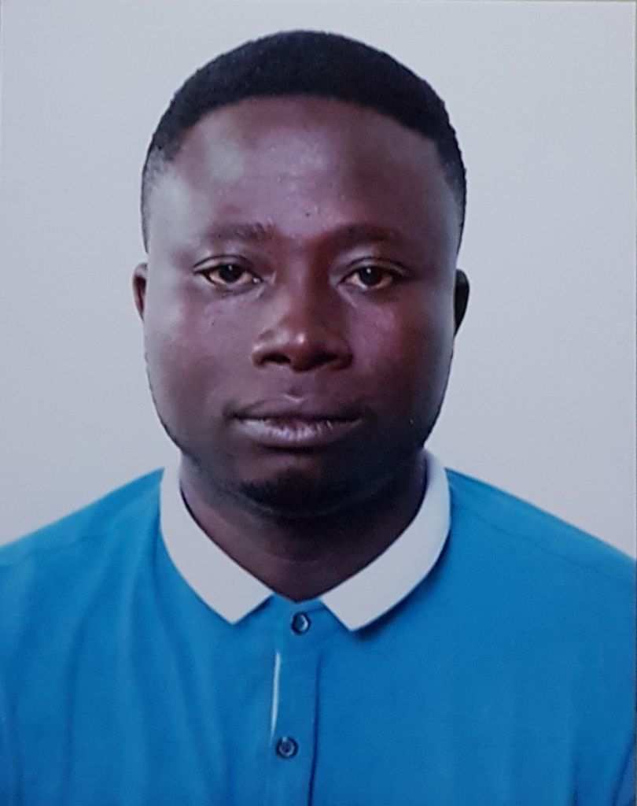
CURRICULUM VITAE (CV)
PERSONAL DETAILS
NAME - PETER OSEI OWUSU
DATE OF BIRTH - 4TH JUNE 1986
GENDER - MALE
NATIONALITY - GHANAIAN
HOMETOWN - MARBANG/BAREKESE
RELIGION - CHRISTIAN
LANGUAGE SPOKEN - ENGLISH, TWI
MARITAL STATUS - MARRIED
PASSPORT NO. - G1815000
C/o IMMACULATE HEART OF MARY'S CATHOLIC CHURCH
POST OFFICE BOX KW 250
KWADASO-KUMASI
EMAIL: oceanpierro@yahoo.com
CELL PHONE: +971553161593

POSITION DESIRED:
Store Helper
OBJECTIVES:
- To ensure that my skills add more value the company’s goal.
- To use my skills to help the company achieve its goal.
- To use the company’s expertise to develop my skills and to attain individual objectives.
SKILLS:
- Strong customer orientation and excellent interpersonal skills, including the ability to work with people from diverse cultures.
- Demonstrate leadership and management skills.
- Innovative in idea generation.
- Good team player.
- Superior planning and time management skills.

EDUCATIONAL BACKGROUND

Institution Location Duration
Assemblies of God Senior High School Ghana 2003-2006
Waj Computer Training School Ghana 2004-2005
Barekese Junior High School Ghana 1999-2001

CERTIFICATION
- West Africa Senior School Certificate 2006
- Certificate in Information Technology 2005
- Basic Education Certificate Examination 2001

WORKING EXPERIENCE
Company Location Position Duration
Apparel Group UAE Parking Helper 3 Months
Alwadi Resorts UAE Security Guard 2019-2021
Intermove Enterprise Ghana Store Attendant 2015-2019
Glee Oil Ghana Ltd Ghana Depot Rep 2013-2015
Osvedas Enterprise Ghana Store Helper 2010-2013

DUTIES AND RESPONSIBILITIES
- Receiving, processing, and organizing shipments and deliveries accordingly.
- Restocking depleted or low shop items and ensuring that the sales floor is organized according to established guidelines.
- Assisting customers in locating desired shop items.
- Informing customers of shop promotions to encourage purchases.
HOBBIES
- Football
- Listening to music
- Reading
- Browsing the Internet

REFFEREES:
Serves upon request

