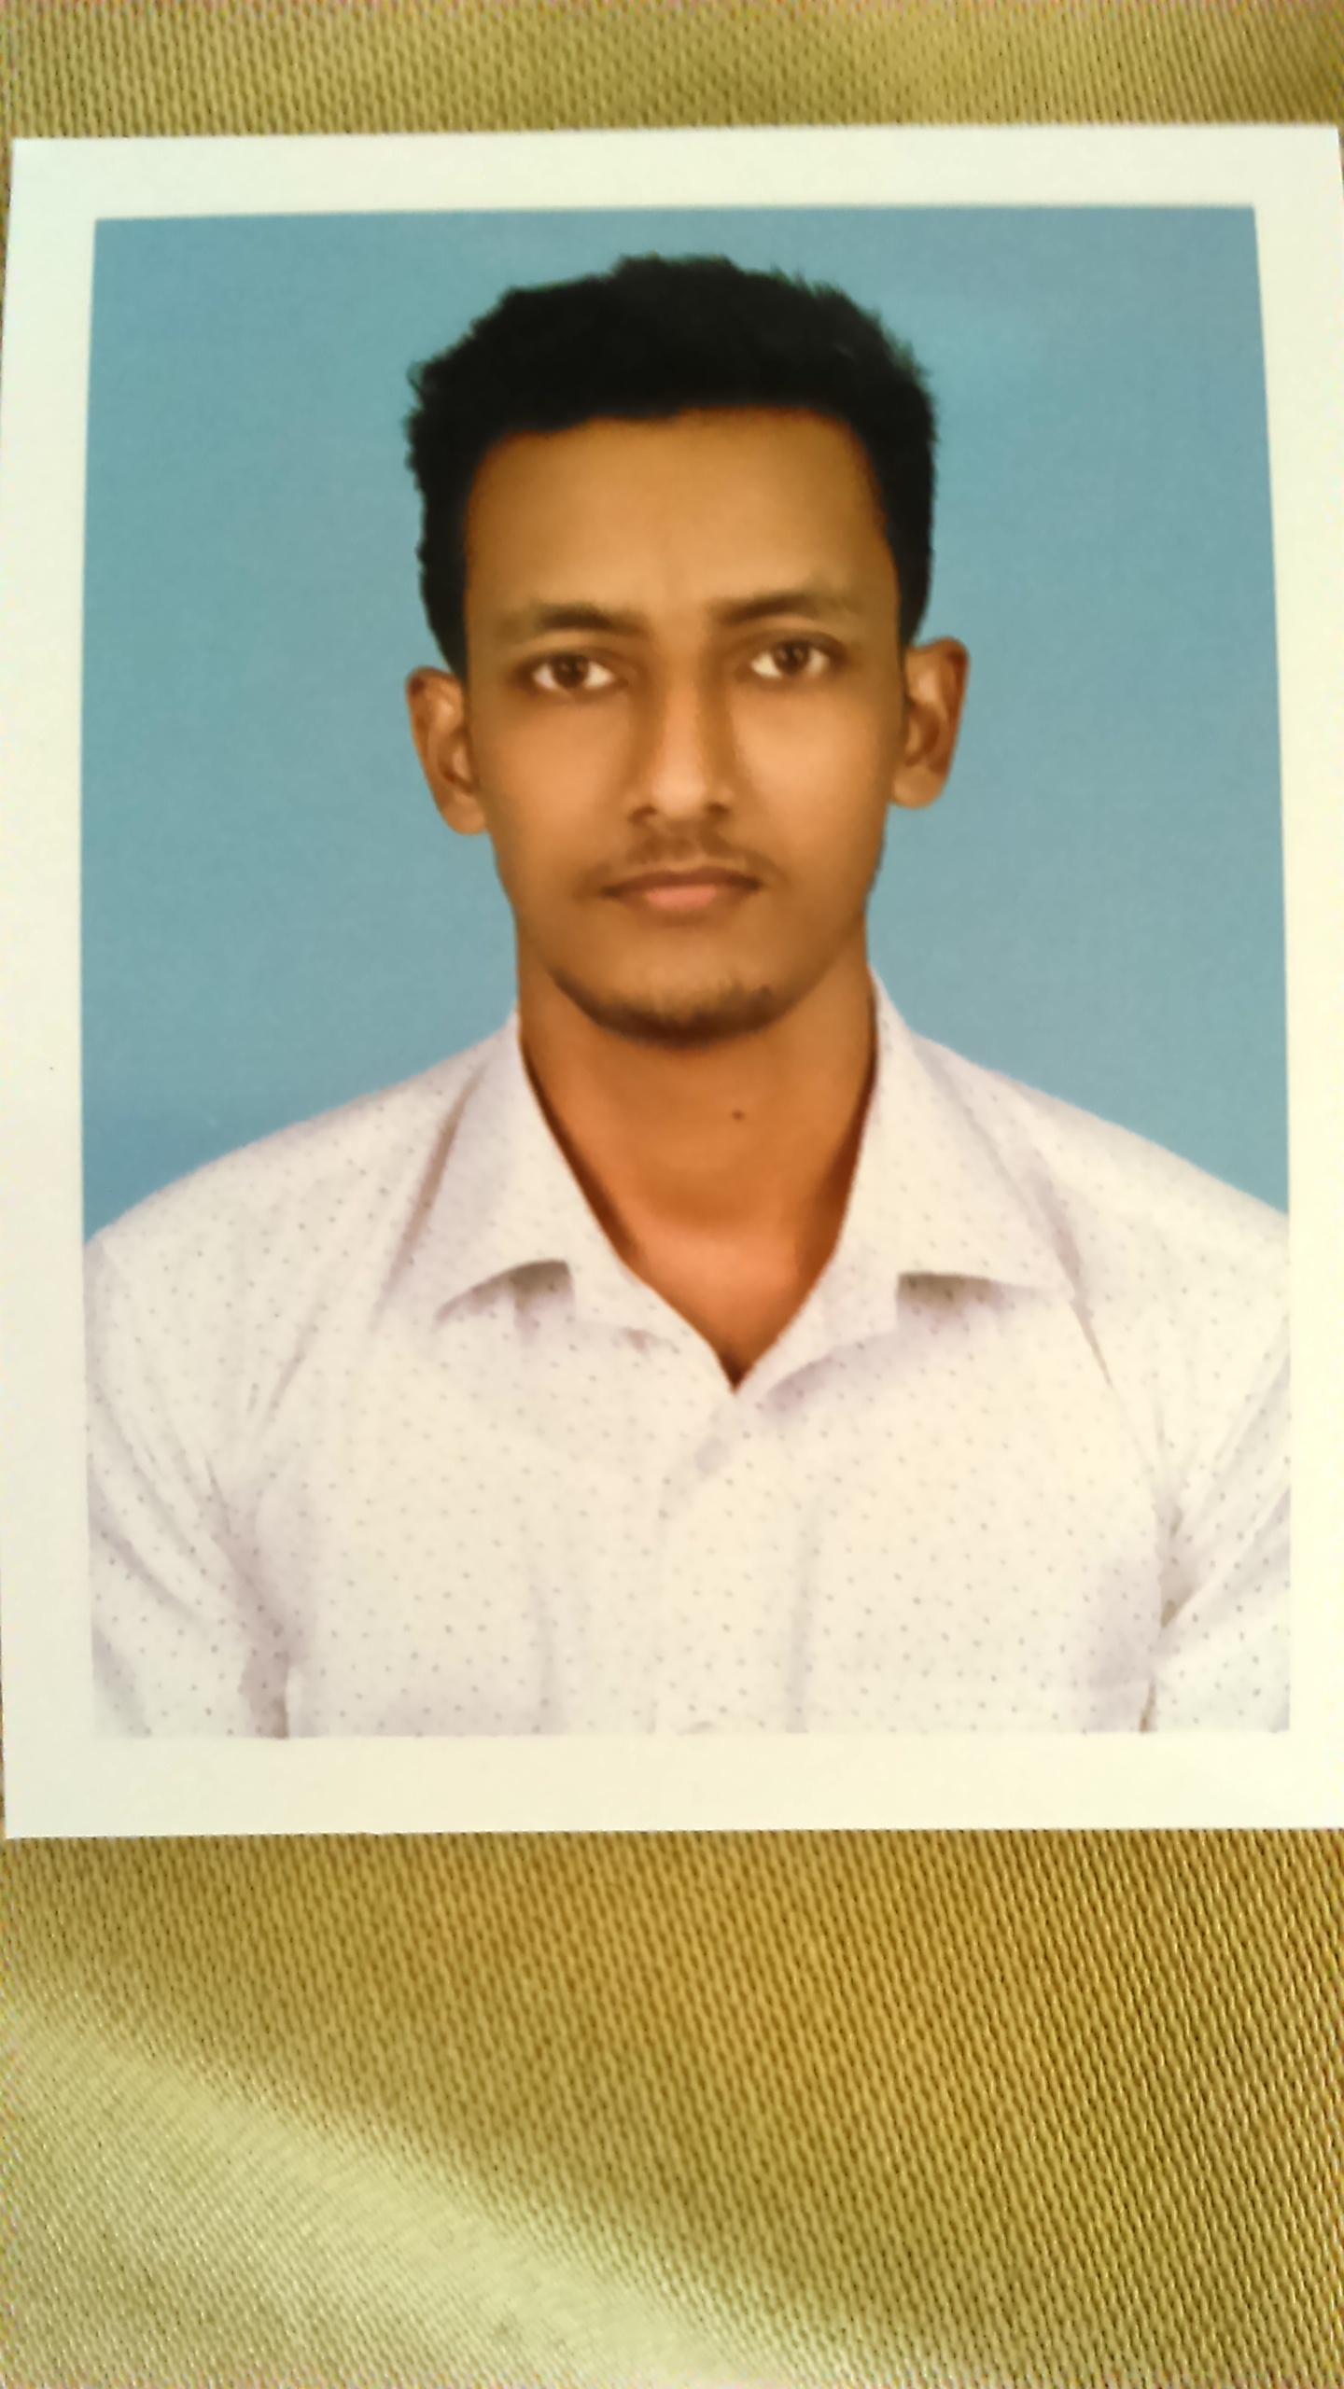
NAME : ISSAC WILSON
S/O- Mr. WILSON .T.V
Personal Data
P.O urakam, 680562
Thrissur District
Date of Birth :
06-08-1995
Nationality : Indian
Marital Status : single

+91 9605300296
+91 8956007185 (india)

issacwilson1995@gmail.com

Address :
Thalikulam House
Poochinnipadam,
P O Urakam – 680 562.
Thrissur, Kerala, India.

To secure achallenging and rewarding position
with Opportunities for personal and career growth, while environment where I can constantly learn and effectively put into practice the knowledge acquired in the formative years of my career and professional life.

. Still working in Om Galaxy Precision Mould Crafts Pvt.Ltd as Accountant
.1year experience in Surya Medicals as Accountant.
.2years experience in Power Lines as Accounts Trainee

. Master of Business Administration
[BHARATHIAR UNIVERSITY, 2016 – 2018]
. Bachelor of commerce
[ MG UNIVERSITY, 2012 – 2015]
. Higher secondary (plus two) [S N College,2010 to 2012]
. S.S.L.C. [G.V.H.S.S. cherpu- 2010].

CAREER OBJECTIVE

EXPERIENCE

EDUCATION PROFILE

C0MPUTER KNOWLEDGE

HHKJHKKJKJJ

IIOIII

. Tally & Quick Books & Peachtree
. MS office
. Windows, 7,8,10, & XP
. FoxPro

DECLARATION

HHKJHKKJKJJ

IIOIII

I hereby declare that all my provided above is true and the best of my Knowledge . finally, I am requesting the concerned authorities to Provide me a chance.

Station: ISSAC WILSON
Date:

