Mohamed Nabawy Morra    Contacts:  Address: King Saud Street,DMM. KSA  Phone: 00966533126836  Email: morra8977@gmail.com  MohamedNabawMorra    @MMorra88    mohamed-morra-864895b6    +966533126836  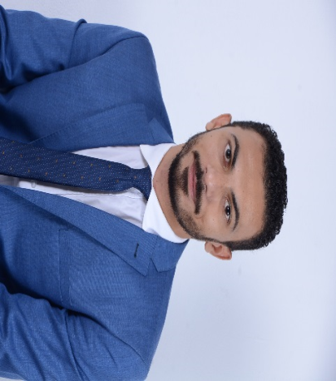  Personal Details:  Date of Birth: 24 /09/1988  Place of Birth : Menofiya, Egypt  Religion : Muslim  Nationality: Egyptian.  Military Statues: Exempted.  Marital Statues: Married.  Driving License: Available (Egypt, KSA).  Languages  Arabic. Native  English. Superior  Qualifications: Bachelor of Accountancy .University of Menofiya. Faculty of Commerce 2005:2009 Grade :(good 73 %)  Mohamed Nabawy Morra    Licenses & Certifications:  - International Computer Driving license " ICDL "from University of Menofiya.  - Intensive Course in Electronic Accounting (Peachtree & Accounting Applications using Excel) from University of Menofiya.  - Intensive Course in English from PSC in faculty of commerce University of Menofiya.  - English Conversation Diploma from International Language Institute.  - Accountant from Ahmed Farag office for Accounting & Auditing.  - Information Technology Officer in Central Food Laboratory (Eastern Province Municipality).  - Calibration and testing lab (ISO 17025: 2005) from Al Farouk Consulting.  - Purchasing Coordinator at Manazel Construction Co.  - Purchasing Coordinator at Al Mandaryah Construction Co.  - Sales & Marketing Supervisor plus accountant at Al Mandaryah Construction Co.  - Attending the seminar (Naizak lab systems Division.  - Attending the seminar (Effective communication skills (the Canadian Training Center).  - Procurement Manager Approved from Royal COMMISSION FOR JUBAIL AND YANBU  - Training for Microsoft Offices programs (IT, Windows, Word, Excel, Access, PowerPoint, Internet) from Information Systems and Technology Center (University of Menofiya).  - References:  Available on request | Professional Summary  - Utilizing & enhancing my skills & qualifications through a big organization which encourages continuous education and development of its employees, and through which I can interact and work efficiently in dynamic environment to prove myself.  - Sales Executive with 8 years of experience working independently and collaboratively with team to foster client relationships and drive sales. Astute in identifying decision makers within prospect account to initiate sales process and deliver successful results.  - Team-minded in collaborating with management to strategies and improve sales approaches.  Skills Highlights  Practical Experience:  Sales Executive ( Key Accounts)– 04/2016: Current Position    ARKAN MFG PAPER CUP LTD, Dammam KSA.  Arkan is a dedicated and innovative company that has highly qualified and  certified professionals in manufacturing high end paper Cups for hot & cold beverage companies. The company works in line with ISO 9001:2015 ISO 45001:2018 ISO 14001:2015 & BRC Issue 6 standards which guide the organisations and capacitate them to consistently provide products and services that meet not only customer, but also applicable statutory and regulatory requirements.  I working as sales executive in selling department and have more than 100 clients and i was follow – up all of this clients and work in target that up to 1 million SAR in this time and seekits achiements monthly.  I am responsible for sales from starting to dealing with the customer & following with him to accepted our offer after approval we arrange our process crossing our facility up to received FG's from our production team up to delivery to the customer warehouse.  Moreover, I am handling all the customers inside & outside Saudi Arabia ALL GCC AREA (PEPSI & COCA COLA & SABIC & Brand Coffee Shops & General Distributors).  Documented daily work in lead development and successful sales, Handled daily customer meetings, sales calls and account management tasks, Coordinated with purchasing manager to negotiate and secure contracts with key clients.  Accomplished in emphasizing service features and benefits, quoting prices, discussing credit terms, preparing sales order forms and developing reports. Expert in overcoming objections from prospective customers to maximize sales opportunities. Hard working and energetic manager and top-rated sales associate with leading dynamic sales teams in fast-paced markets. Sales Executive focused on customer satisfaction throughout all stages of sales life cycle.  Purchasing Coordinator – 08/2014: 03/2016. 1yr 8 mo  Manazel Construction Company ,Dammam Saudi Arabia.  Manazel Construction was established in 2006 as a limited liability company, then it was transformed into a closed joint stock company in 2013 with a paid-up capital of 300 million riyals. Since its inception, the company has implemented several projects in the governmental and commercial sectors.  My responsibility is purchase everything and all needs for site which I handling and get a great offers from suppliers, by relation in market and experience, negotiate to get the best price and make comparison.  Make contracting with contractors, coordinate and manage a project for the company.  Received inbound phone calls from store managers and facility management associates, creating work orders and purchase orders to replace faulty or unsafe equipment or conditions.  Generated weekly, monthly, quarterly and yearly reports on purchasing operations.  Sales & Marketing Supervisor – 06/2010: 03/2014.3 yr 9 mo  AL MANDARYAH Construction CO, Jubail Saudi Arabia.      AL MANDARYAH Construction - Limited Liability Company -possesses competence and experience in the field of contracting and trade, and the company has paved the way for it by implementing many projects and facilities for the public and private sectors. the company pays most attention to its customers, whether in the current government projects or private sector projects focused in the eastern region of the Kingdom of Saudi Arabia.  responsible for all equipment and work on the organization of work in an integrated manner to achieve maximum rate and work on marketing the company's services and collect payments from customers match those services. Analyzed departmental documents for appropriate distribution and filing. Supported Chief Operating Officer with daily operational functions. Delivered an exceptional level of service to each customer by listening to concerns and answering questions.
  - Project management  - Decision maker  - Complex problem solver  - Market intelligence  - Sales and market development  - Excellent communication skills  - Social media savvy | - Customer relations  - Service promotions  - Sales territory growth  - Brand-building strategies  - Sales process

