CURRICULUMVITAE
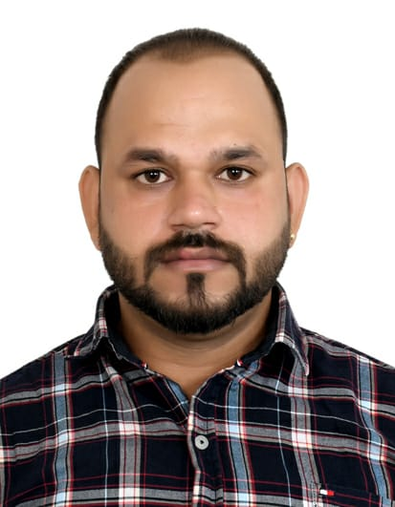

ROHIT YADAV
Current Add:-Industrial Area 15 Sharjah,UAE
Mob No.: +971502550752
Email Id: rohitymw@gmail.com
Visa status : Visit-visa

CARRIER OBJECTIVE

To makea positive impact in my field of activity leading to Organization growth by creative application of my value based convictions and professional divinity by putting my all efforts in the work assigned to me in an organization where I can grow along with the organization.

EDUCATIONAL QUALIFICATION

- Bachelor Of Business Management(BBM Hons.) completed from Dayalbagh Educational institute (Agra) in the year of 2014
- Senior Secondary. PassedfromP.S.E.B(Punjab) in the year of 2010 with the 1st Div.
- Matric passed from P.B.S.E(Punjab) in the year of 2008 with 1st Div.
WORKING EXPERIENCE

- 3 years experience as ‘Sales Man’ in Metro Store(Punjab)(May 2018 to Sept. 2021
- 2 years experience as ‘Sales Man’ in Bonn breadat Ludhiana(Jan 2016 to March 2018)
- 1 year experience as ‘Sales Man’ in Big Bazaar at Ludhiana.(Aug. 2014 to Dec. 2015)

KEY SKILLS

- Strong Inter-personal organizational skills.
- Sincerity towards job and punctuality.
- Able to cope under pressure.
- Very meticulous and versatile.
- Excellent communication skills.
- Can work independently or as a part of team.

RESPONSIBILITY OF JOB

- Maintaining and developing good relationship with customers through personal contact or via telephone
- Asses customer need andprovide assistance and information about product features
- Welcome customers to the store and answer their queries
- Maintain in stock and presentable condition assigned area
- Helping management in forthcoming products and discuss on special promotions.
- Reviewing their own performance and aim at exceeding their targets.
- Keeping record of sales and order information and report the same to the sales department.
- Providing accurate feedback on future buying trends to their respective employers.
- Identifies product improvement or new product by remaining current on industry trends, market activities and competitors.
- Maintain Inventory, Accuracy, Sanitation levels and fulfill customer.
- Recognised for determination in setting and achieving sales goals and exceeding..

ITSKILLS/ COMPUTER PROFICIENCY

- Knowledge of Ms-Excel,Ms-word, Ms office-
- Knowledge of Adobe Photoshop & E-mail.

PERSONAL INFORMATION

- Name ROHIT YADAV
- Father’s Name RAVINDER YADAV
- Date Of Birth 30-March-1992
- Marital Status Single
- Languages Known English,Hindi,Punjabi & Udru
- Religion Hindu
- Nationality Indian
- Hobbies Reading Books of history, Gymnastics
- Address 1989 Abdullapur Basti Ludhiana Punjab( 141003)
- Temporary address Sharjah, (UAE)
- Visa ststus Visit visa

PASSPORT DETAIL

Passport No. | Issue Date | Expiry Date | Place of Issue
P6005118 | 13-01-2017 | 12-01-2027 | Chandigarh

DECLARATION

I, the undersigned, certify that the above statements are true to the best of my knowledge and belief.

Date : …………………………..
ROHIT YADAV
Place : …………………………. (Signature)

