MATHAN BABU V
DIPLOMA IN ELECTRICAL AND ELECTRONICAL ENGG

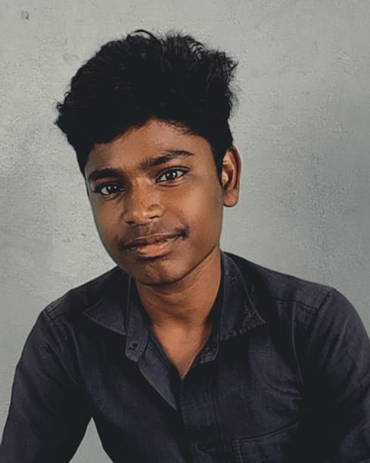

OBJECTIVESSeeking a challenging opportunity in an organization to excel and grow along with the organization by utilizing my knowledge and acquired skills towards fulfillment of organizational vision

HOBBIES
- Playing cricket
- Listening Music
- Watching movies

CONTACTS/o S .Vellaichamy,7/956
, Vamapuram,
Sengulam(po), Aruppukottai(Tk), Viruthunagar(Dt),Taamilna du-626114

Flexography Machine

EDUCATION

- SSLC-2017 ----------------------------------------- 86%
Govt.Hr.Sec.School.Poolangal

- HSC-2019 ----------------------------------------- 57%
Govt.Hr.Sec.School.Poolangal

- DOTE-2021 ------------------------------------------- 91%
Sri Sowdambika Polytechnic Collage, Aruppukottai.

LANGUAGES KNOWN

- TAMIL
- ENGLISH

u
DATE : Singnature

PLACE :

